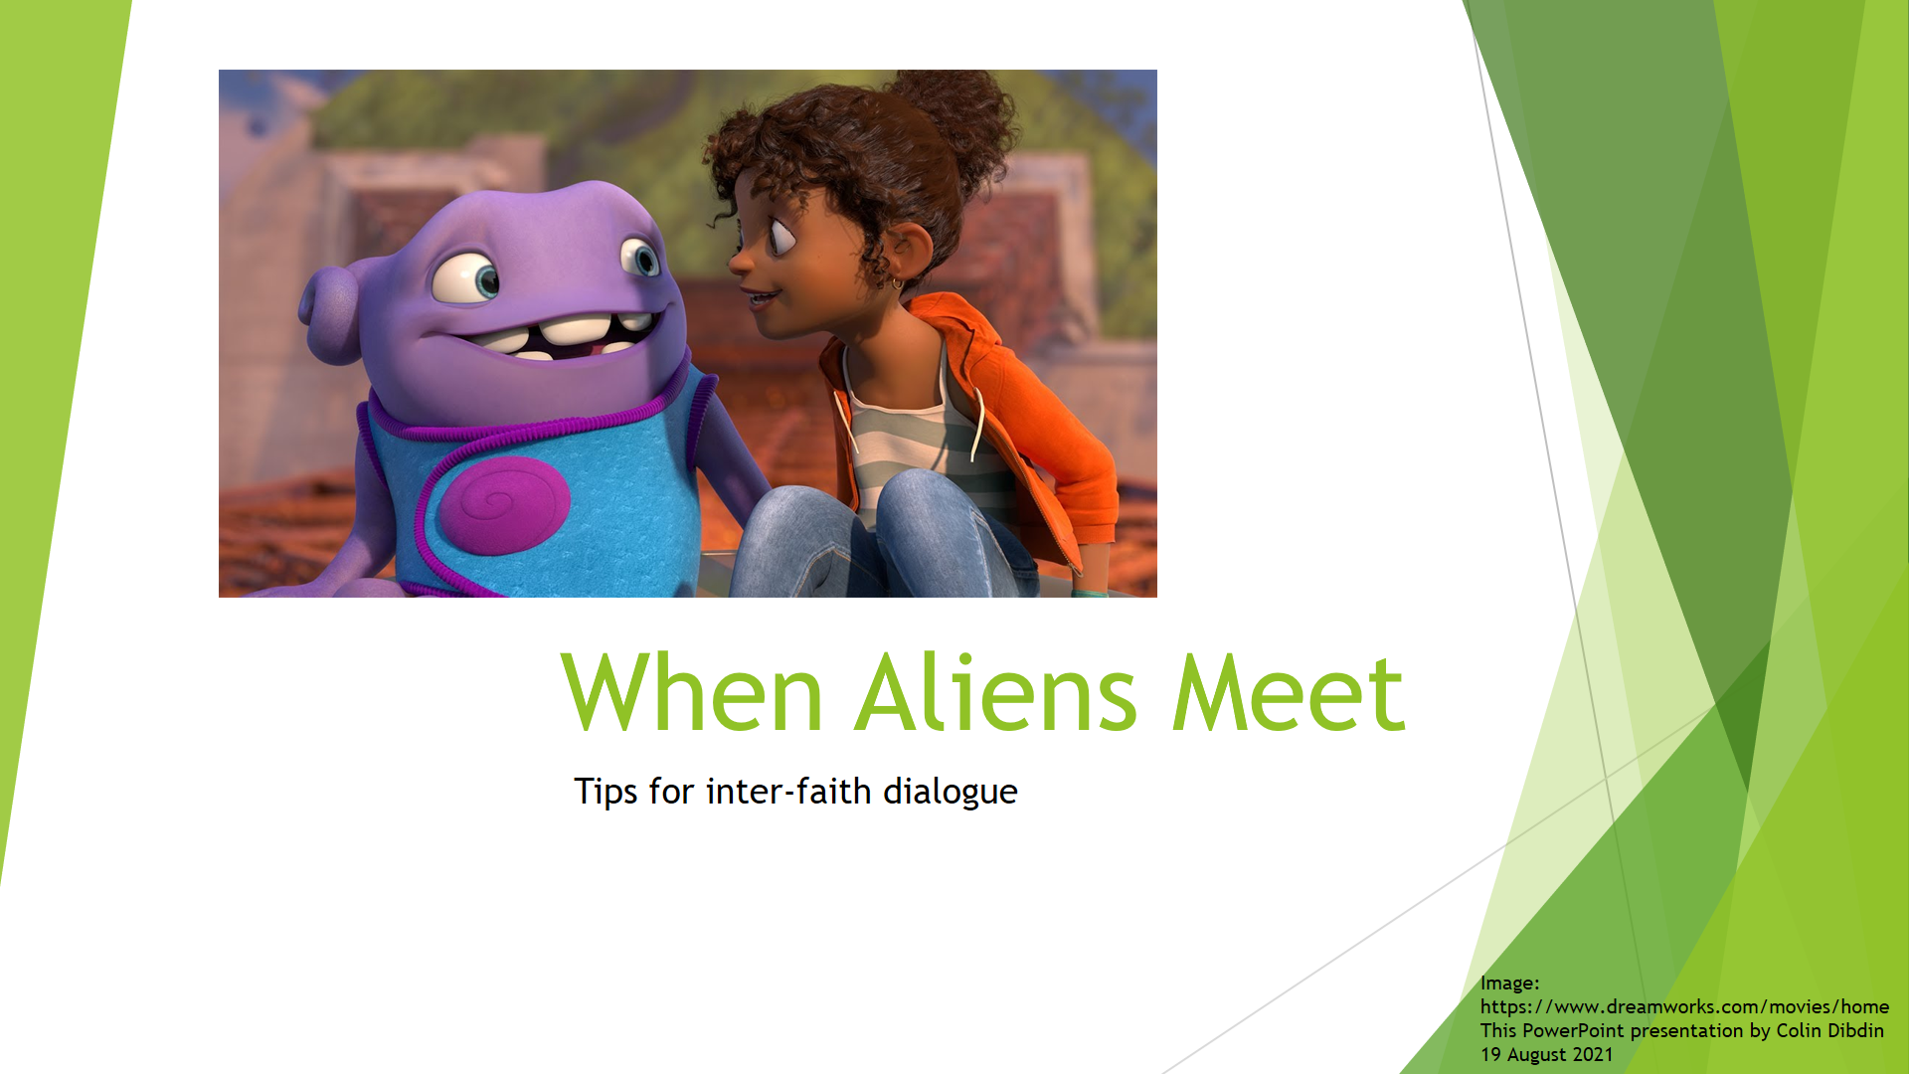

Tonight you will learn some tips and principles to help you talk to people about controversial subjects such as religion.

However this presentation is not just about tips and techniques. It’s about how we see each other. Do we see a friend or an alien?
How many aliens are there in this picture? Which one is the alien? Can you tell by just looking at the picture?

Not long ago we described people from other countries and other planets as aliens. We did not care much that they looked different, spoke their own languages, had exotic religions. We could ignore them and sometimes fight them. We did not need good personal relationships with aliens. Now the planet has shrunk. Our communities are diverse. Even our families are diverse. The aliens of the past are now our neighbours, our work colleagues and our family members.

What are the challenges?

Let me give you two example from my neighbourhood:
- The first was a kind, elderly, gentle and hospitable man in the local shopping centre whose business included doing horoscopes and astrology. He also practiced Catholicism and Buddhism. I greatly respected him but one day I was challenged because he told me he admired Hitler. I felt myself getting upset.
- The second is a likeable family man. He has been to my house of worship and my family has been to his synagogue. We have collaborated in study groups and children’s spiritual education. We get on well. However!!! A few weeks ago he promoted the anti-vaccination rally in Sydney. I felt disturbed by that.

I will tell you later what happened.

By the end of this presentation you will remember three principles of interfaith dialogue, which you can practice next time you talk to someone whose beliefs seems strange or wrong. For the moment I will just name these concepts:
- Humility
- Trust, and
- Empathy

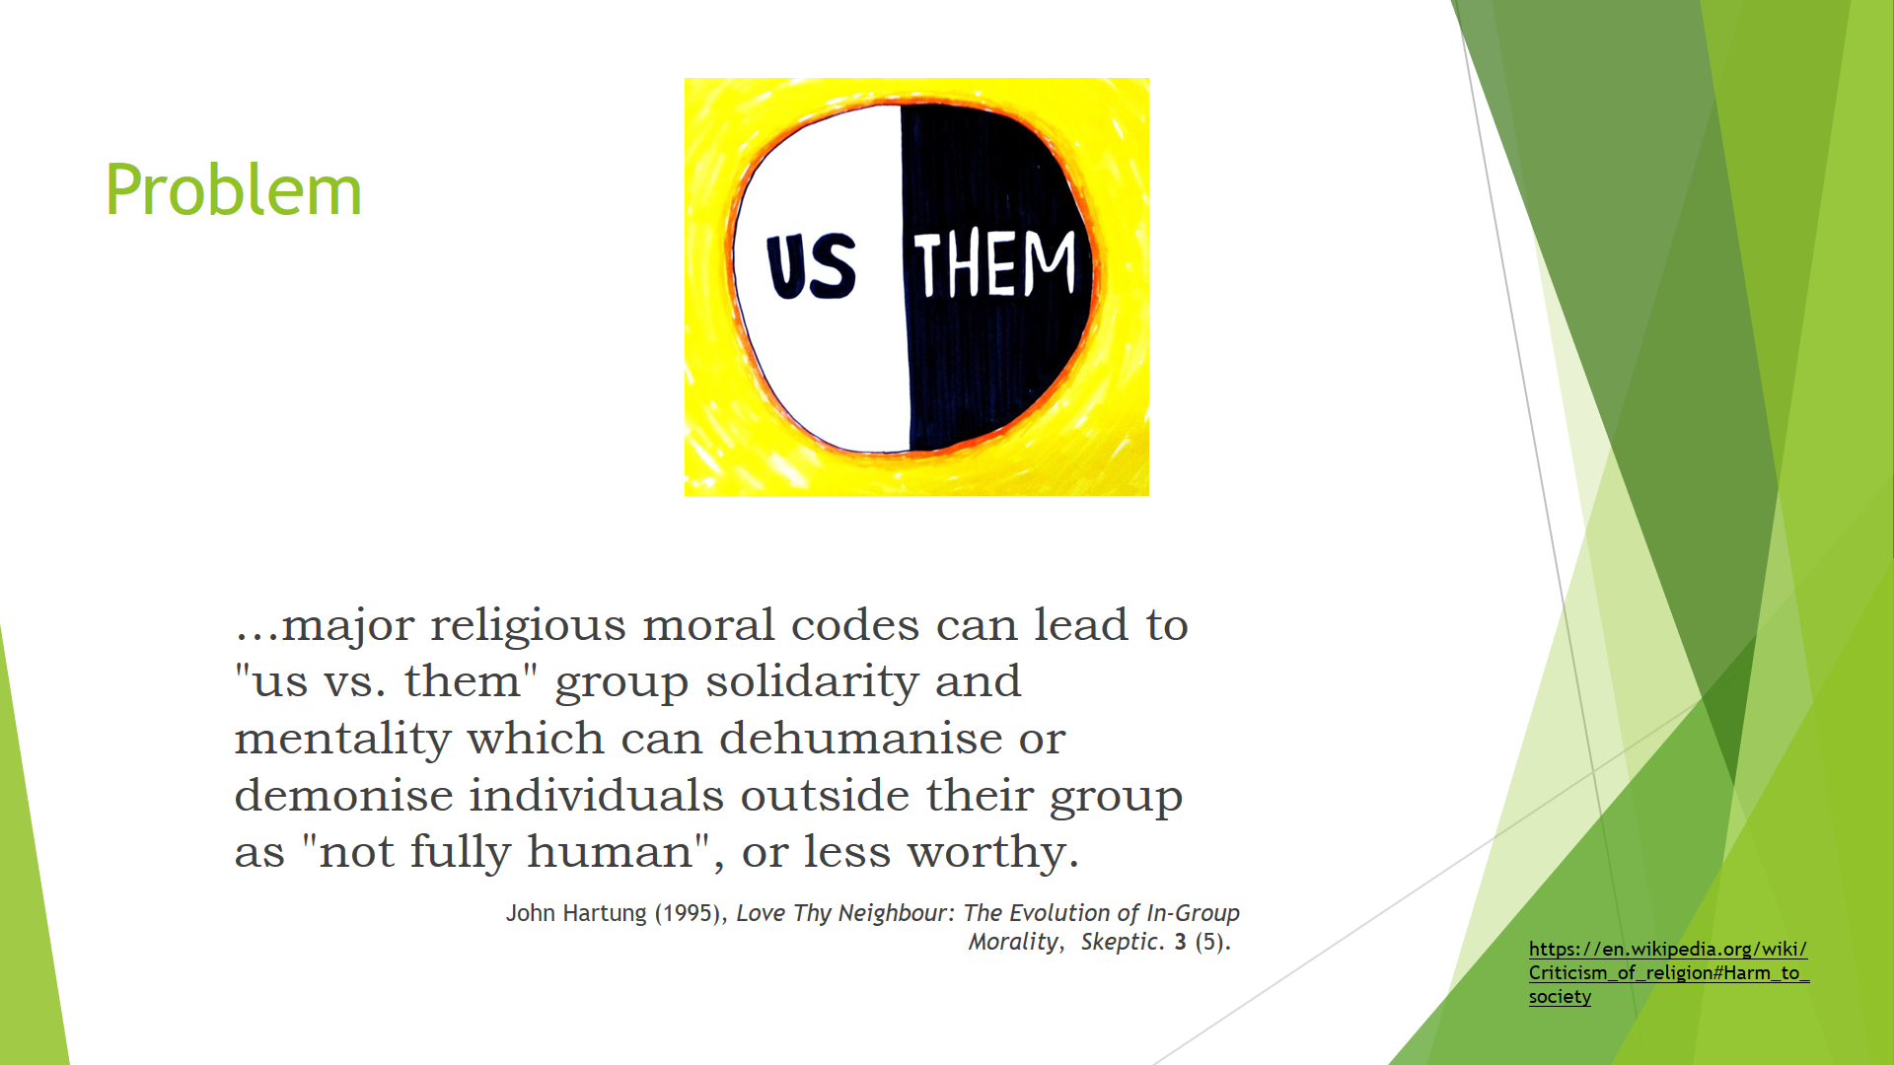

Why has religious prejudice been difficult to overcome?

One writer claimed that “major religious moral codes can lead to "us vs. them" group solidarity and mentality which can dehumanise or demonise individuals outside their group as "not fully human", or less worthy. Results can very from mild discrimination to outright genocide. [John Hartung (1995), Love Thy Neighbour: The Evolution of In-Group Morality, Skeptic. 3 (5).]

A poll by The Guardian noted that 82% of the British people believe that religion is socially divisive.

And yet there is a more positive way to think about our exposure to different religions. Stephanie Dowrick is Interfaith minister at Pitt Street Uniting Church in Sydney. She was quoted in a book called The Quiet Revolution: The Emergence of Interfaith Consciousness. Ms Dowrick said:

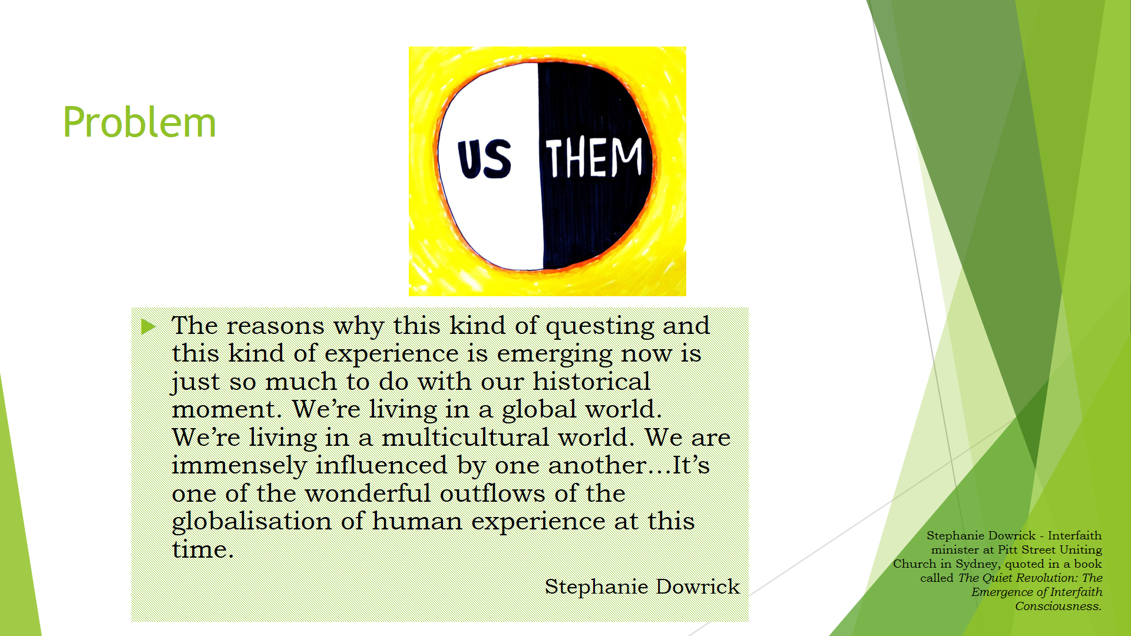
The reasons why this kind of questing and this kind of experience is emerging now is just so much to do with our historical moment. We’re living in a global world. We’re living in a multicultural world. We are immensely influenced by one another…It’s one of the wonderful outflows of the globalisation of human experience at this time.

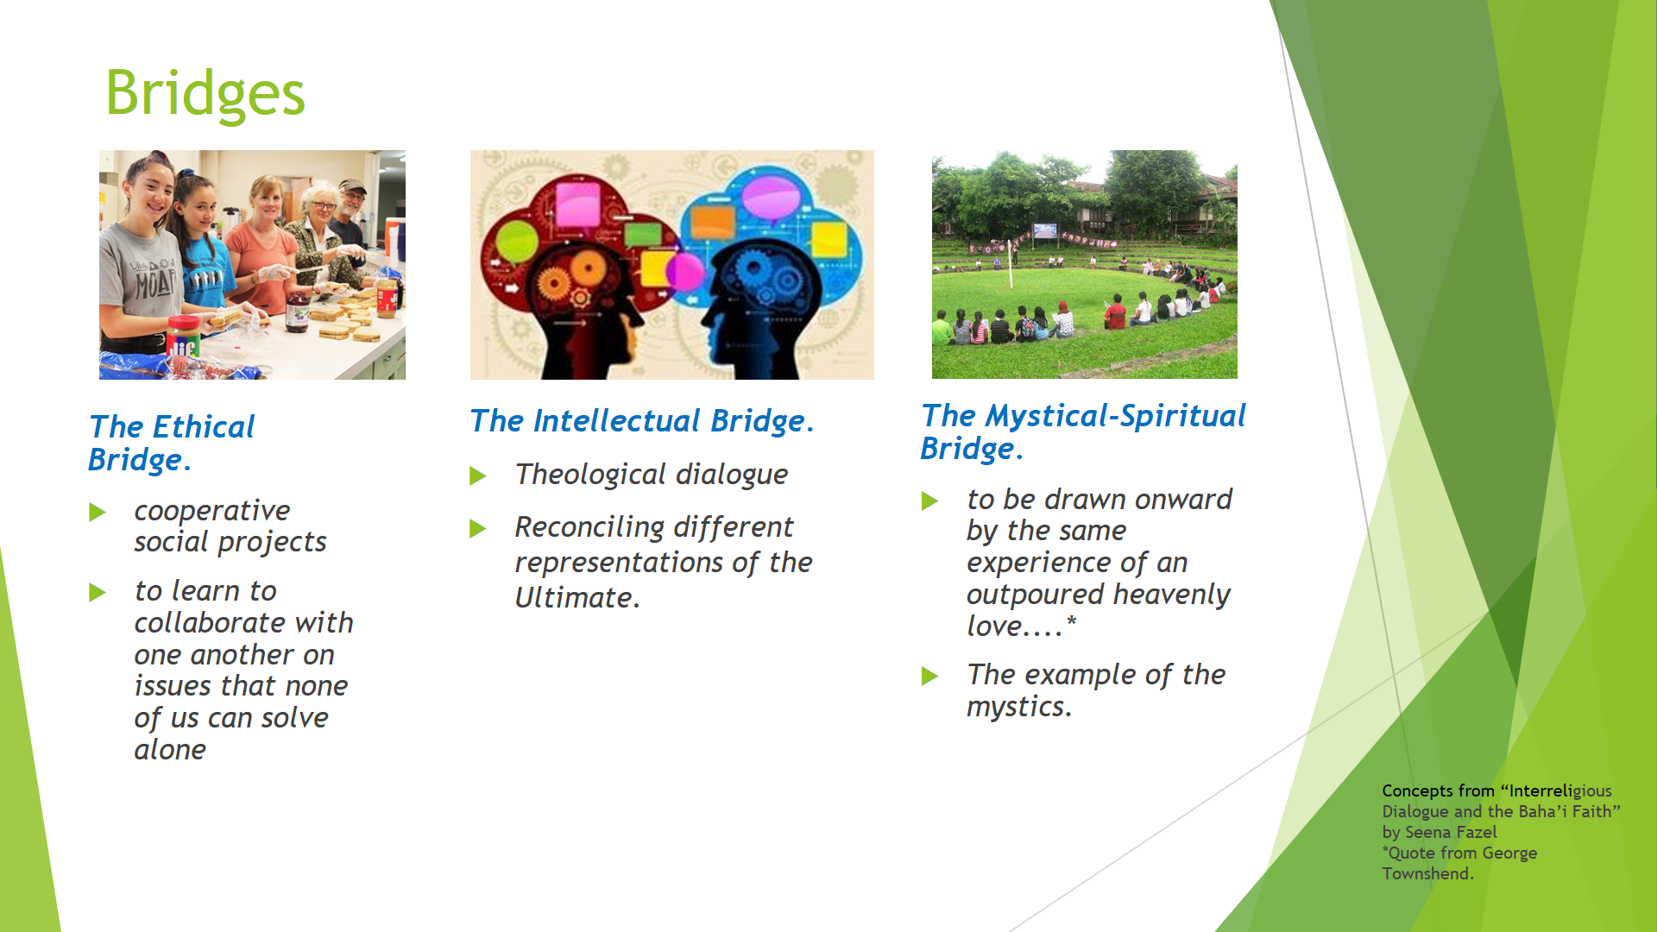
The Globalization of Human Experience. How do Faiths build bridges with each other?

Dr Seena Fazel describes three “bridges”: Ethical, Intellectual and Spiritual.

Here are some examples:

The Ethical Bridge.

When I lived and worked for two years on a small Island in the Pacific Ocean, 1600km from Sydney. I met the ministers of the Anglican, Uniting, Catholic, Seventh Day Adventist churches. I had good friends in all of the churches and I participated when I could. Here is an example of a difficult situation resolved by a cooperative social project: Some elders in the Seventh Day Adventist Church believed that the Catholic Pope was “the antichrist”. Father Harry (I never learnt his last name) was the Catholic Priest at the time. He did not take offence at what the other church believed about his church. Rather he saw the opportunity to have a bit of fun. When it was Father Harry’s turn to do the weekly church radio program he described himself as “The Pope of Norfolk Island”. Not only that he called his car “the Popemobile” and he got number plates “666” which is described in the Bible as “the mark of the Beast”. Now this sounds like a recipe for inter-faith disaster, don’t you think? Well it could have been. It wasn’t. You see the Catholic congregation was quite small and they could not afford a church organ. But the Seventh Day Adventists raised most of the funds to buy the Catholic church a new organ. And the churches co-existed in harmony, which is a good thing considering they live on a speck in the Pacific only 5km wide by 8km long. It shows that deeds mean more than words in inter-faith relations.

The Intellectual Bridge.

A friend of mine is a theologian. He has served in the Vatican and has published many books about Jesus and the Bible. With his permission I have used his books in my interfaith dialogue courses, because he has a broad, spiritual and empathetic outlook on other religions. We caught up with each other at a wedding and he told me that his latest book compares the New Testament with the Qur’an. The Qur’an is the holy book of Islam. I read that book and told him that I disagreed with his conclusion that the Qur’an promotes violence. He replied “Yes it does and pointed out that some of my statements were not factual”. So I decided to educate myself on the subject as best I could. It took two years of reading and thinking but now I feel comfortable to continue the dialogue, next time I see him.

Theological dialogue is a most fascinating and exciting area, with great writers such as Hans Kung, John Hick and Montgomery Watt. However I only want to offer one thought. In matters of theology and belief each religion has a reasonably straightforward and internally consistent worldview. Each makes a lot of sense on its own. But when you compare and contrast it gets quite complicated. You cannot reconcile differences in a few meetings and conference of theologians or leaders or historians. This kind of work needs personal research, quiet reflection, careful expression of views, respectful scholarly discourse mostly in peer-reviewed journals or books, and then progress can be made slowly and steadily over decades. I’m not saying that you and I cannot contribute to this – we can. But we have to be careful not to oversimplify and ignore differences.

The Mystical-Spiritual Bridge.

Spiritual dialogue is "a primary path" to understanding other religions.

I do not believe in reincarnation, but by mere coincidence, I was born within an hour or so of the passing of George Townshend. Wikipedia says “George Townshend was born in Ireland and was a well-known writer and Anglican clergyman who converted to the Baháʼí Faith at age 70.” He represented the Bahá'í community at the first World Congress of Faiths in 1936. In that presentation, he said this:

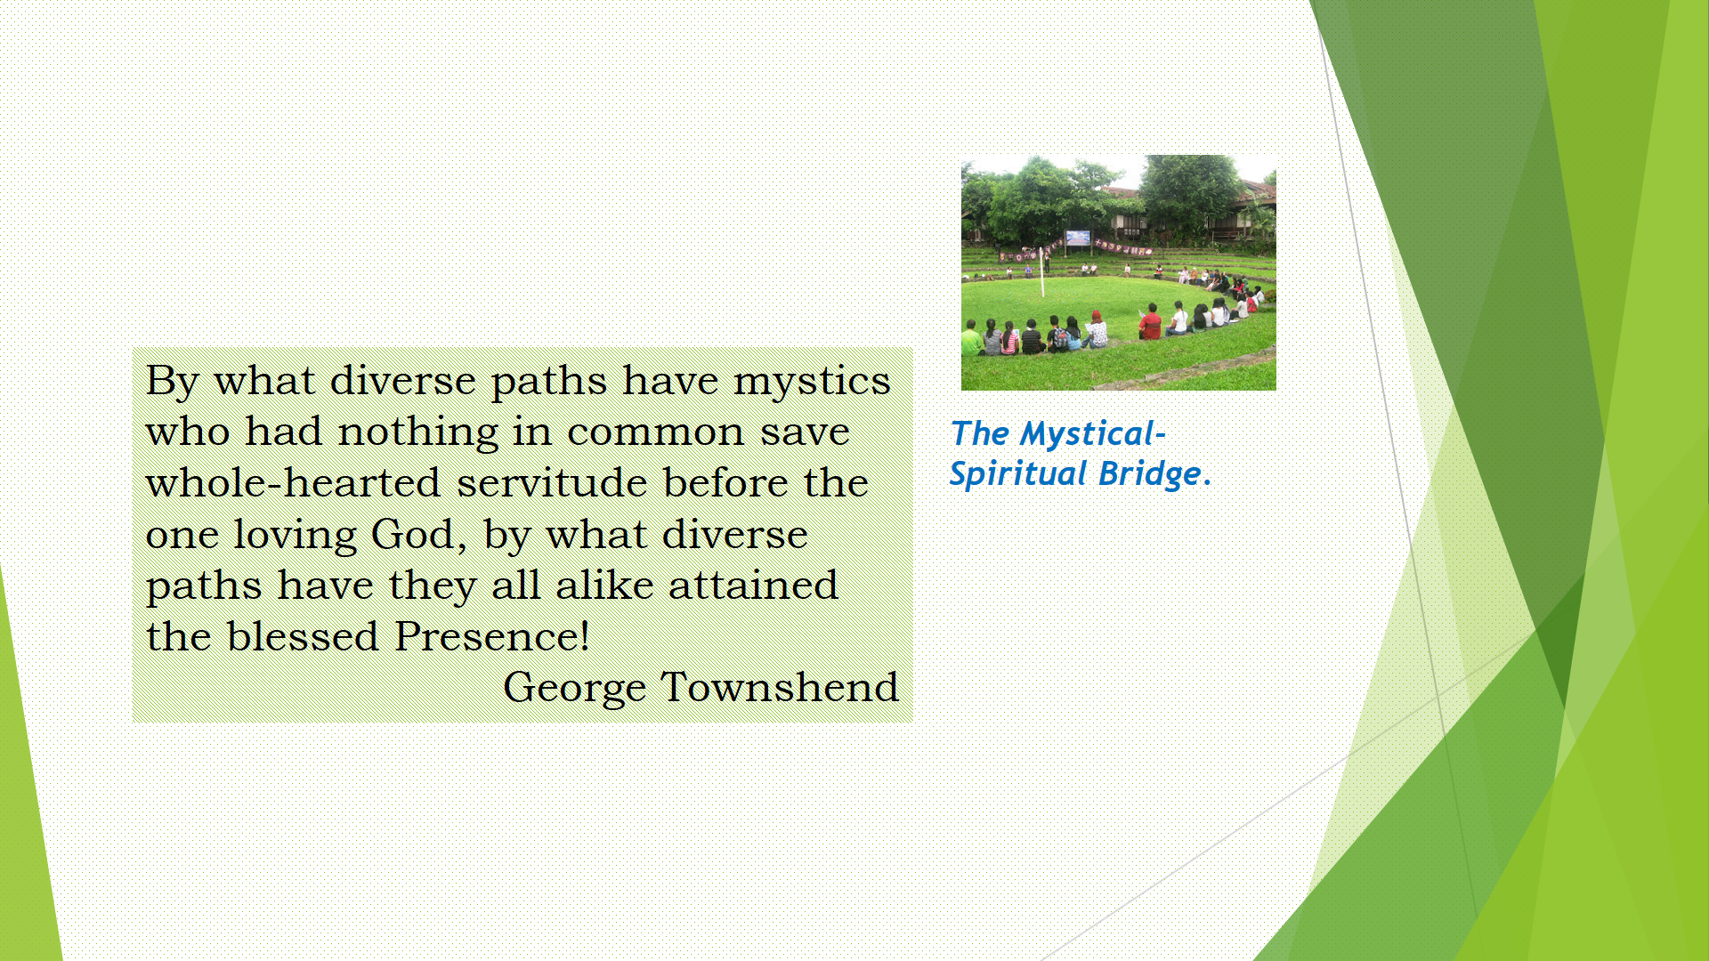

By what diverse paths have mystics who had nothing in common save whole-hearted servitude before the one loving God, by what diverse paths have they all alike attained the blessed Presence!

I almost wish I believed in reincarnation, because then I could imagine myself inheriting the courage and perception of George Townshend. He could see this spiritual bridge.

Sharing our prayers and sacred writings can enable us to cross this bridge.

In 1985, when was a studying at the University of NSW, three students died when the car they were travelling in left the freeway and hit a tree near Goulburn. One was a Baha’i, another was Buddhist, and the third was a Christian. The three communities came together to organise an interfaith memorial service at the University. No group felt any need to diminish another. All were drawn together by sadness and hope. The service was dignified and spiritual. In their prayers and readings it was clear that they all spoke with one voice. There was unity between those present.

These bridges – ethical, intellectual and spiritual – create shared experiences but there are still difficulties!!!!!!!! What sometimes happens when we have interfaith meetings? Here are three challenges you might find:
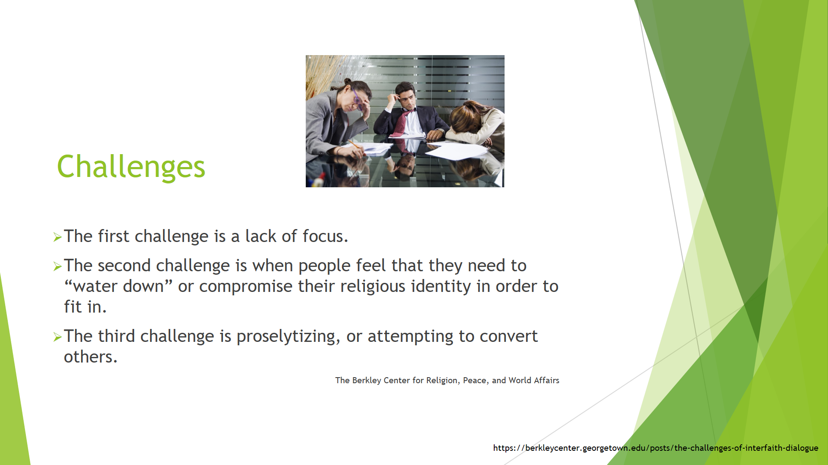

- The first challenge is a lack of focus.
- The second challenge is when people feel that they need to “water down” or compromise their religious identity in order to fit in.
- The third challenge is proselytizing, or attempting to convert others.
The Berkley Center for Religion, Peace, and World Affairs

I won’t attempt to describe those, but let us go straight to some principles that address such challenges.

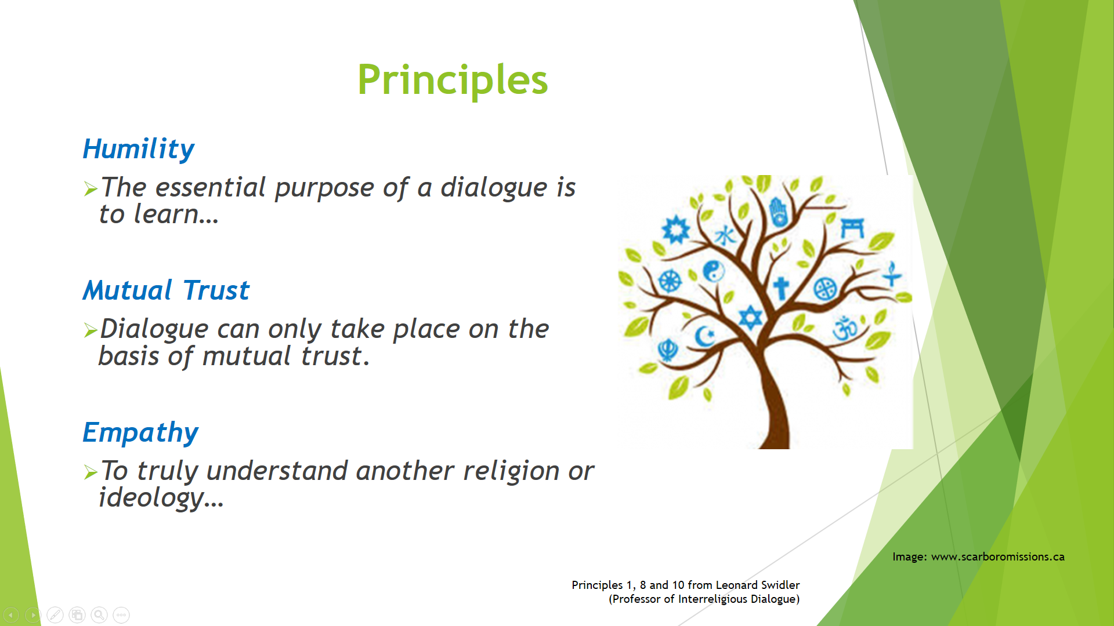

- The essential purpose of a dialogue is to learn.
- Dialogue can only take place on the basis of mutual trust.
- To understand another religion or ideology one must try to experience it from within

Dialogue is conversation between between people with differing views. Professor Leonard Swidler, identified ten rules for dialogue. In this presentation I only briefly look at just three which I have abbreviated to: Humility, Mutual Trust and Empathy.

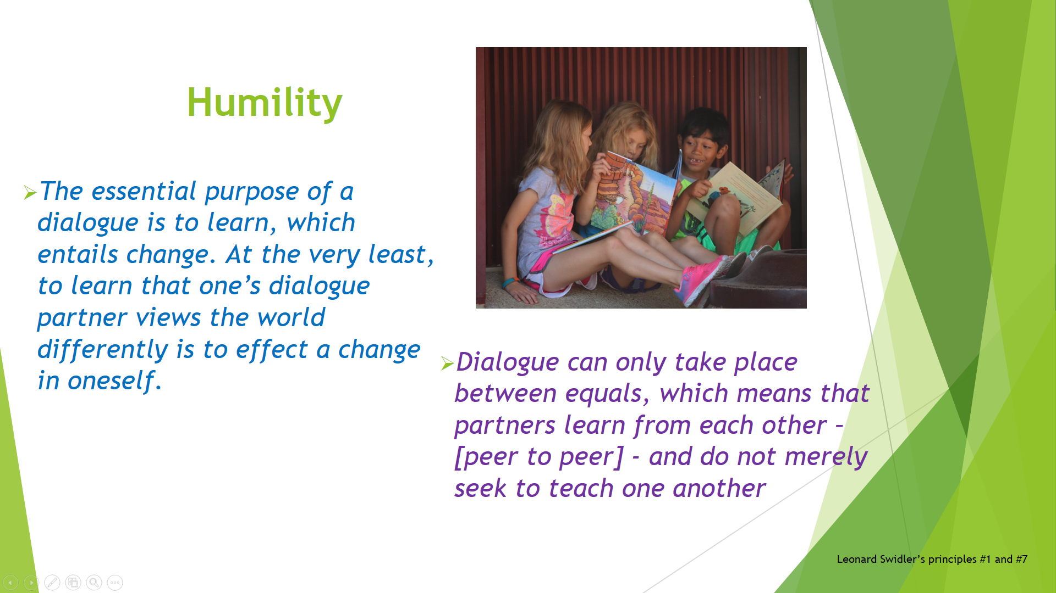

“The essential purpose of dialogue is to learn.” (Swidler)
AND
“Dialogue partners do not merely seek to teach one another.” (Swidler)

To be a learner is to be humble. I have to subdue my prejudices and my ego while listening, if I want to learn something.

Imagine a classroom with two teachers. Imagine that, by some improbable circumstance, each believes that the other has enrolled to be their student. But the student will not sit down and listen. The student thinks he or she knows better and interrupts the teacher. The teacher gets upset with the student. Both get upset. That’s what religious discussions sometimes look like. When they eventually realise that both are teachers then they agree to take turns to listen, and both start to enjoy the encounter. And if they are learning about religion, and they are not arguing, then maybe God will be the teacher.

DISCUSSION LATER “What can we do when people at interfaith meetings attempt to convert others?”

Leonard Swidler, in an online video interview (Wilmette Institute), was asked that question. He gave two useful tips:
- George is speaking. Listen carefully to what “George” says. Then say “Let me see if I understood you correctly George”. Then George can respond and correct you. Address George as another person without giving the feeling that you are trying to trick him. Reflect what he said. Tr to get the conversation to focus on issues rather than feelings.
- When you are speaking, use “I” statements. Don’t say “Everyone know that x is not true”. Don’t say “You have got it wrong”. Respond based on your experience. Say “I think this…” “My experience is this…”.

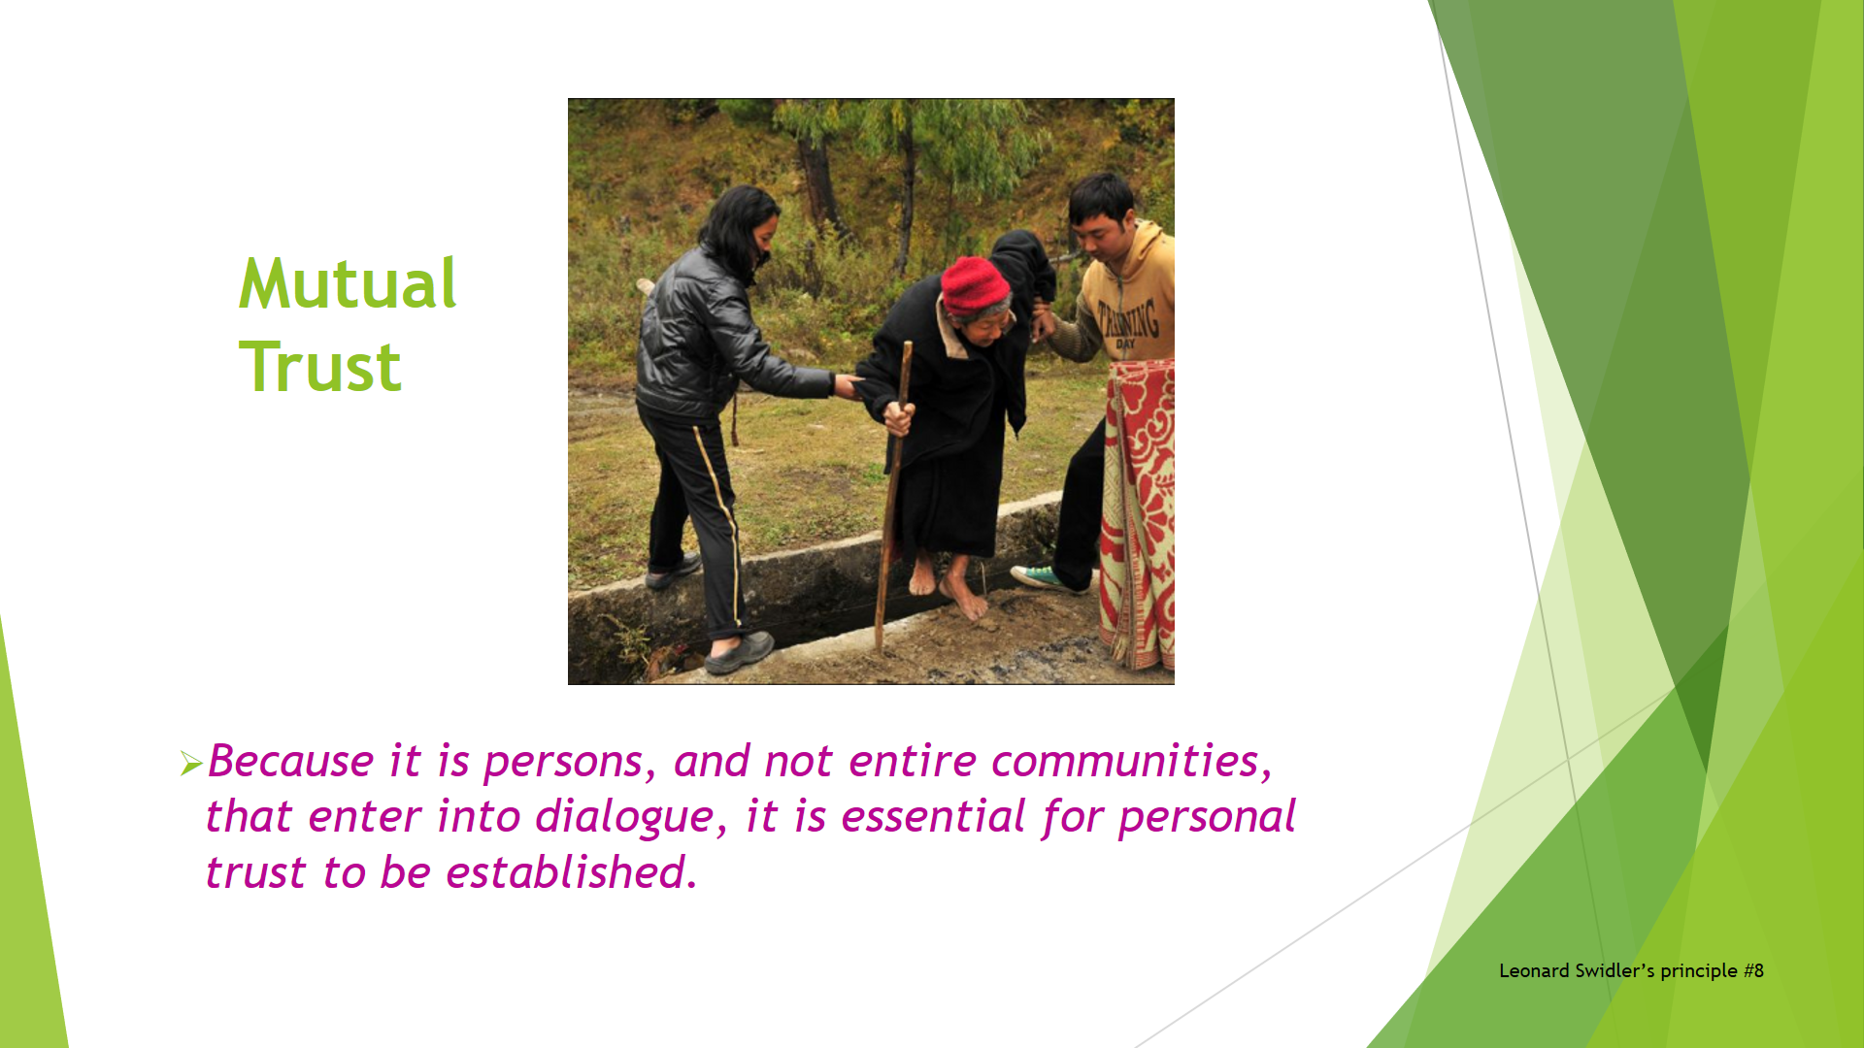
“Dialogue can only take place on the basis of mutual trust. Because it is persons, and not entire communities, that enter into dialogue, it is essential for personal trust to be established. To encourage this it is important that less controversial matters are discussed before dealing with the more controversial ones.” (Swidler)

Why does trust make a difference?

Hugh Mackay wrote “People who feel insecure in a relationship are unlikely to be good listeners.”

Hugh Mackay’s book is called “Why Don’t People Listen?” Here is some of the best writing I have found about building trust: He wrote:

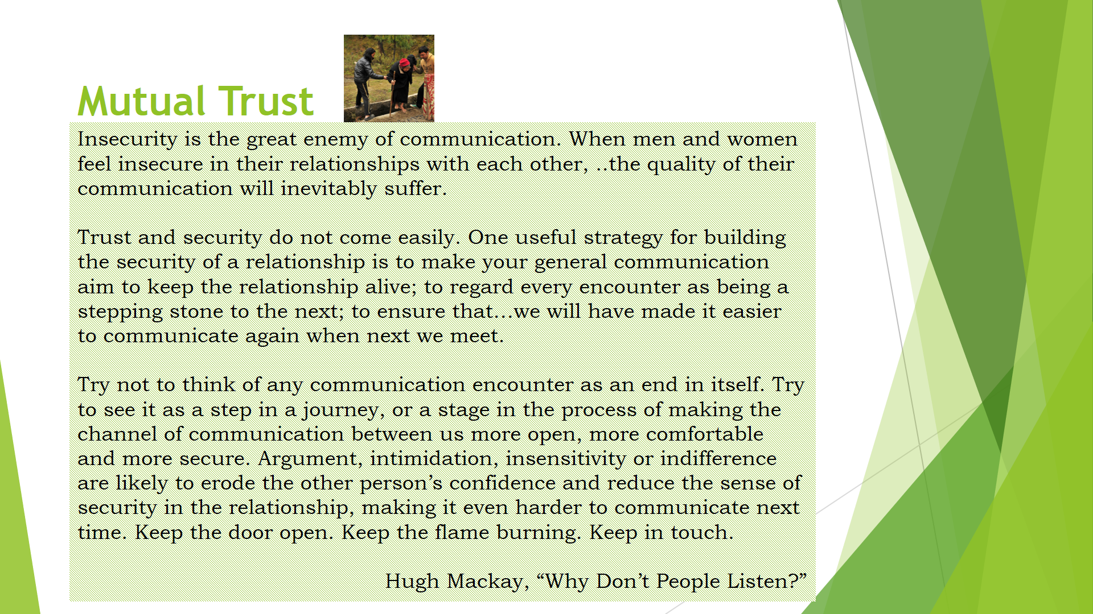
Insecurity is the great enemy of communication. When men and women feel insecure in their relationships with each other, ..the quality of their communication will inevitably suffer.

Trust and security do not come easily. One useful strategy for building the security of a relationship is to make your general communication aim to keep the relationship alive; to regard every encounter as being a stepping stone to the next; to ensure that…we will have made it easier to communicate again when next we meet.

Try not to think of any communication encounter as an end in itself. Try to see it as a step in a journey, or a stage in the process of making the channel of communication between us more open, more comfortable and more secure. Argument, intimidation, insensitivity or indifference are likely to erode the other person’s confidence and reduce the sense of security in the relationship, making it even harder to communicate next time. Keep the door open. Keep the flame burning. Keep in touch.

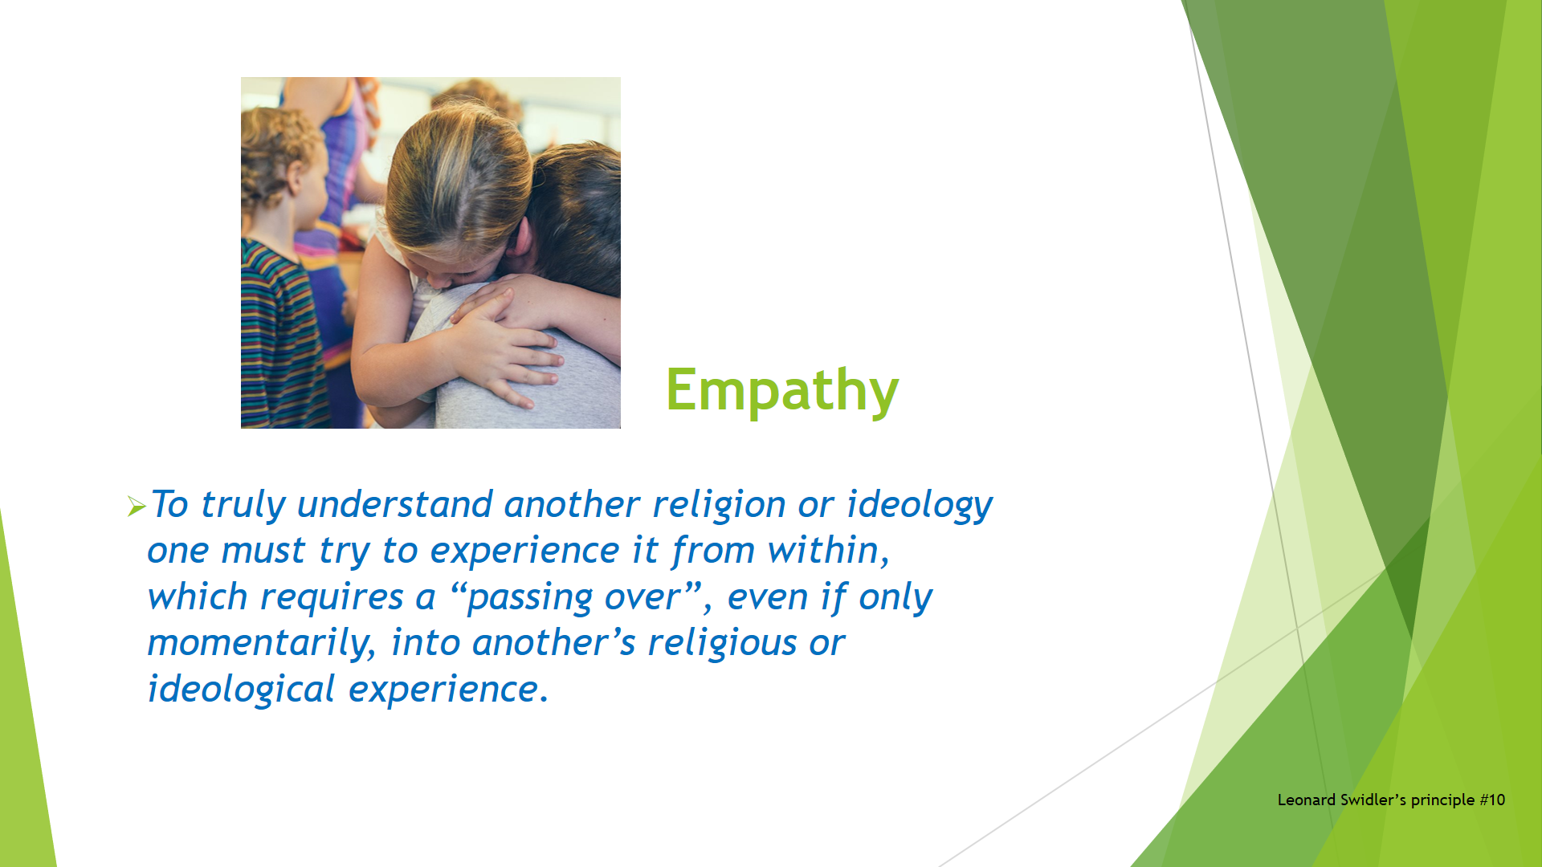

“To truly understand another religion or ideology one must try to experience it from within, which requires a “passing over”, even if only momentarily, into another’s religious or ideological experience.” (Swidler)

This is different from collaborating on an activity, or comprehending another’s belief. It is more like sharing a feeling.

DISCUSSION LATER - I doubt that anyone could completely experience another person’s inner state. For one thing it is ‘inner’. Also, no two people are the same. And our own inner voice constantly interrupts. There are also psychological barriers such as fear.

- The idea of 'conversion' can be a source of fear, if it means your familiar community might reject you.
- Another is that one may be 'playing with fire' by seeking to learn from another religion which one has been taught to see as misguided or evil.
- Yet another is the natural fear of being defeated in argument, whatever the subject.

As you can see, there are barriers to trying to experience another religion from within.

Techniques and skills are not enough, in my opinion, to create true understanding or empathy or compassion. What is needed is love – the kind of love described by Jesus. “To love the Lord your God with all your heart and with all your soul and with all your mind and with all your strength” and “love your neighbour as yourself”.

When we do this, and others do this also, and we do not let prejudice obscure our vision, then we are, I believe, essentially entering into their religious experience. This is very helpful for dialogue.

To conclude, here are two ways that humility, mutual trust, and empathy, are likely to make interfaith dialogue more constructive:
- New questions we might ask, and
- What we might find.

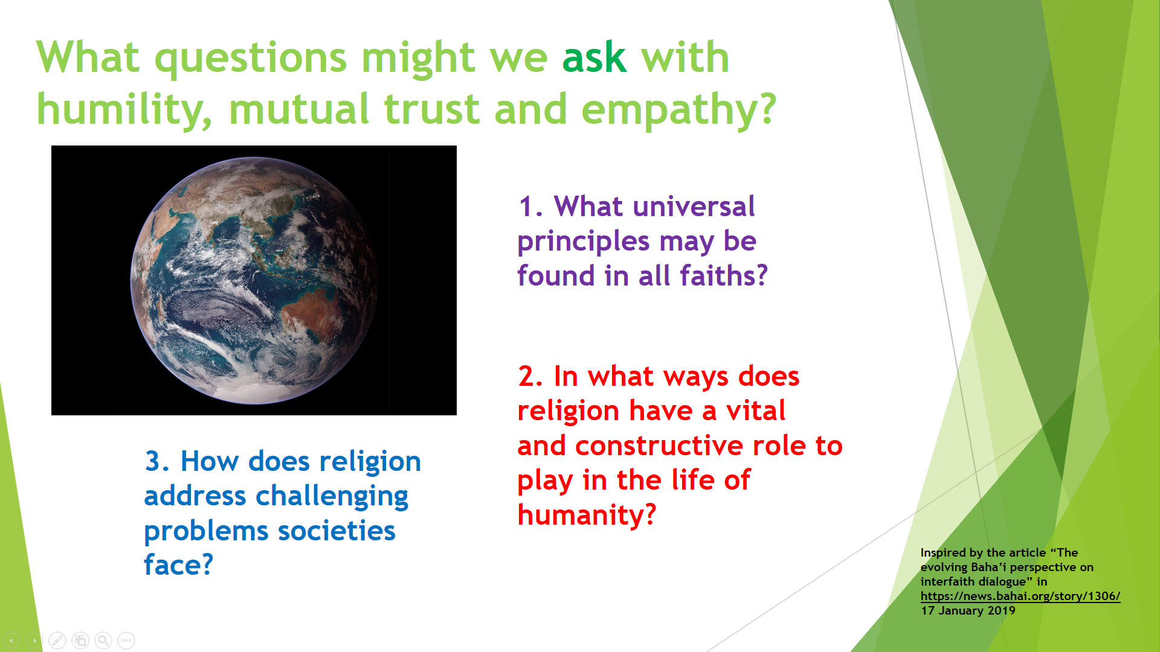

What are some constructive questions might we ask people of other faiths when we start to see them with humility, mutual trust and empathy?

Maybe questions like these:
- What universal principles may be found in all faiths, and what can we learn from each other's experiences applying them?
- In what ways does religion have a vital and constructive role to play in the life of humanity?
- How does religion address the challenging problems societies and nations face as well as broader societal well-being?

In the next slide I’ll share something about the constructive role of religion. At this time in history the world does not turn with confidence to religion. Why? Because some people of religion cannot even talk kindly to each other.

But first, I should finish those two stories. What happened between my neighbours. Remember? One admired Hitler. I was upset with his views. The other promoted the recent anti-vaccination rally. I was uncomfortable about his views AND his behaviour.

- With the elderly gentleman, instead of arguing I asked him why, and he told me – because Hitler was a strong leader and created order in his society. I was still upset, and I still wanted to change his mind (that is, to “teach” him) but I refrained. At least now, because I asked him a question, I could understand a little of his reasoning, and I did not close the door to further discussion.

- With the neighbourly family-man, I knew that he already felt himself to be under attack because of his anti-vaccination views. If you look at the media, including social media, you will see a lot people either debating or trying to educate people who don’t trust scientists or officials. But, just like interfaith dialogue or political debate, it doesn’t work. We need to be calm, listen, respect people’s fears, and build trust and don’t expect instant results. If the subject comes up then my strategy is to acknowledge that it is not easy to trust authorities these days, and to find some more points of agreement.

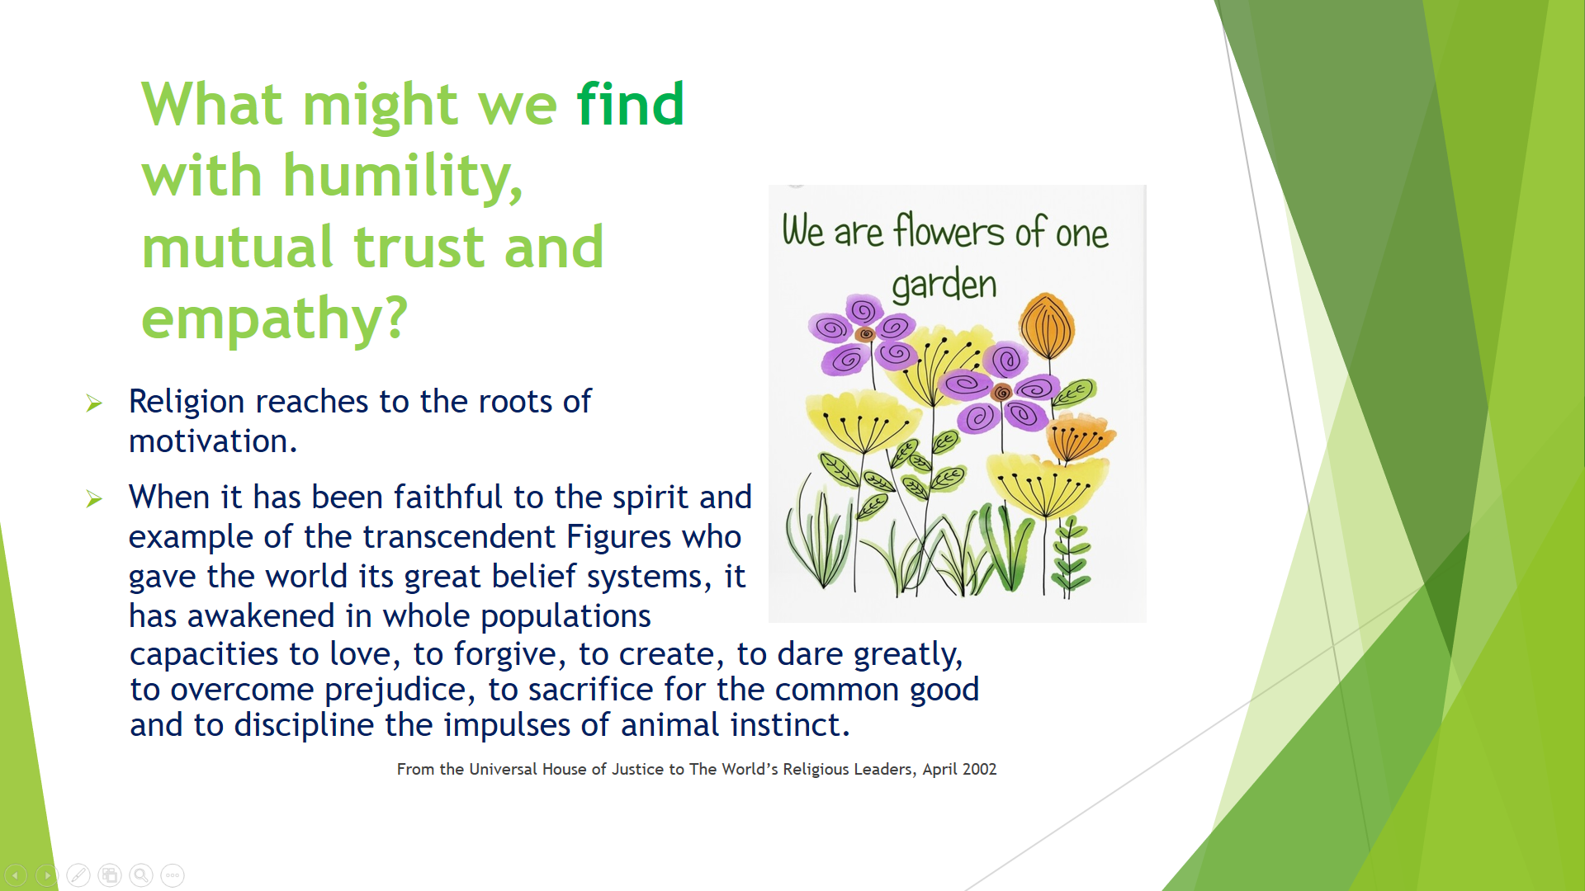

What might I find when I look into other belief systems with humility, mutual trust and empathy?

I have found that religion, when it is true to its founding principles and not clouded with superstition or exclusivism, is indispensable, like air and water. It sustains me, it helps me to grow, and it has a universal quality.

Religion reaches to the roots of motivation. When it has been faithful to the spirit and example of the transcendent Figures who gave the world its great belief systems, it has awakened in whole populations capacities to love, to forgive, to create, to dare greatly, to overcome prejudice, to sacrifice for the common good and to discipline the impulses of animal instinct.
From the Universal House of Justice to The World’s Religious Leaders, April 2002

Is my religious identity at risk by learning about others?

Dr Christopher Buck, at an interfaith conference a few months ago, expressed this view which appeals to me. He said:

“I am a Baha’i. But I have a broader identity as a world citizen, as a child of God, as a brother to you – spiritually and physically.”

And, remember, if you meet an alien, do these things:
- Have the humility to be a learner
- Build mutual trust
- Be empathetic

