Thursday Night Interfaith Presenters
This update 8 June 2023

Mrs Ruth Abner  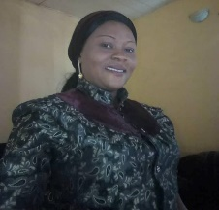 | #34 - 12 August 2021 - Love for your Neighbour - Mrs Ruth Abner  Ruth Abner, a Nigerian and a mother of two she works with Nigerian Immigration Service, and in part time with Omnia Institute for Contextual Leadership, trained by Shanta Prewamathana.
Mr Kannan Ambalam  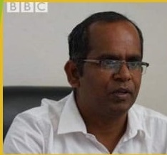 | #60 - 10 February 2022 – Building community infrastructure in Ethiopia - Mr Kannan Ambalam https://www.youtube.com/watch?v=9nJtME476sU  Dr. Kannan Ambalam is originally from Tamil Nadu, India. He has B.Sc. in Chemistry, M.A, M.Phil, Ph.D in Public Administration. He has been a lecturer in the Department of Public Administration & Development Management at Wollega University, Nekemte, Ethiopia since 2009 and currently he is an Associate Professor. His fields of interest are: Public Administration, Sustainable Development, Food Security & Food Sovereignty, Community development, Water Governance.  He has published and contributed to books and articles and he is on the editorial boards of several international journals.  In Ethiopia he has inspired his students and public and worked with them in the field to build many access roads, water springs and bridges in remote and rural areas using local resources. His service has been appreciated by organisations in both Ethiopia and India.  https://www.thehindu.com/news/national/tamil-nadu/kannan-ambalam-an-inspiration-for-communities-in-ethiopia/article32300227.ece  https://eoiaddisababa.gov.in/republic-day-2022-reception-26-jan-2022/  https://wollegauniversity.edu.et/index.php/professionals-in-community-services
Ms Angela Ambrosia  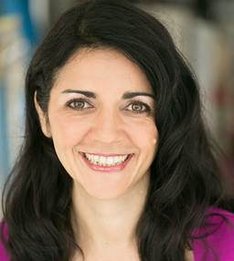 | #59 - 3 February 2022 – Near Death Experiences – Finding Meaning through Death - Ms Angela Ambrosia  Angela Ambrosia is healer, movement and meditation teacher and shares classes and workshops to help youth learn about self-acceptance, body awareness and body confidence with the intent of establishing a school for young and old to learn about love, self-acceptance and enlightenment.  In 2019, she had a near death experience after going into a coma from an aggressive ovarian and uterine cancer. In the years since her recovery, Angela realized how she denied her own knowing that she was not going to die because she believed what the hospital and others thought was true. She is aware of how much we allow the power of others’ beliefs to overshadow our own knowing. And encourages others to learn how to listen to your inner voice while also inviting and creating spaces to share yourself with others and experience true connection.  In her Workbook the Body of Love http://amzn.to/2o28JFB, she explores 10 Steps to experience the Energy Body and the emotions of the self and transform the way you perceive your body.  http://www.DancewithAngela.com
Ms. Aisha Amjad  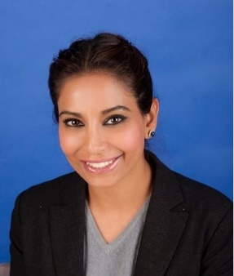 | #93 - 29 September 2022 – Let us find comfort where we overlap and strengths in our differences- The inner faith of interfaith - Ms. Aisha Amjad http://www.youtube.com/watch?v=vOmK1zuVxT8  Aisha is an accomplished young leader across law, politics, media and international relations. Aisha has a strong focus on Interfaith Dialogue and Multicultural Affairs, and works passionately on building productive relationships between communities and cultures. Aisha’s work with women from ALL countries is her passion and purpose in life as she believes there is nothing more powerful than women helping women, because when they do with the solidarity of sisterhood, amazing things start to happen. Small ripples become miracles which flow forth, spreading more goodness and lifting others on the way.  https://www.facebook.com/aisha.ak.16  https://www.wef.org.in/aisha-amjad-australia/
Dr Ahmad Aniss  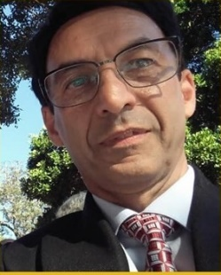 | #33 – 5 August 2021 – Key to Prophecies in The Book of Certitude – Dr Ahmad Aniss  https://www.youtube.com/watch?v=3Xg6rBhCZ7Q  #81 - 7 July 2022 - Creator and Created: A Personal View - Dr Ahmad Aniss http://www.youtube.com/watch?v=vYlj8msLEIo  Dr Aniss was born in Iran. He spent his youth in the UK and then migrated to Australia. He is a Baha’i and he has an educational background in Engineering and Medicine, and his experience includes roles as an Associate Lecturer, Research Officer, Technical Support Officer, and is currently working as a Medical Researcher and database manager. His interests are theological and astronomy topics.
Prof Mrs. Rathi Arumugam  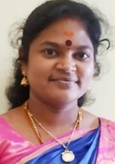 | #90 - 8 September 2022 - Chisel your Mind with Positive Thoughts - Prof Mrs. Rathi Arumugam http://www.youtube.com/watch?v=G0RWgjTEY4E  Dr. V. P. RATHI from Tamil Nadu, India is currently an Assistant Professor of English at Mannar Thirumalai Naicker College. Having obtained B.A, M.A, M.Phil., PhD in English, she started teaching in 2007.  She has authored four books, co-authored four books, and contributed chapters to 12 books, and published several research papers and articles. She is a poet too.  She is concerned about the wellbeing of the society and uses her YouTube channel for altruistic purpose.  https://www.youtube.com/channel/UCFTJX7i9smh9jVSXN5dPtkQ/videos
Miss Liyana Rosli Asmara  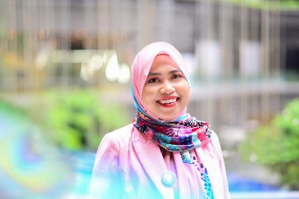 | #52 - 16 December 2021 - Finding Strength and Healing through the Story of Maryam (Mary) in the Quran - Miss Liyana Rosli Asmara https://www.youtube.com/watch?v=83N7wSP8Ew8  Miss Liyana Rosli Asmara holds a Bachelor of Islamic Revealed Knowledge and Heritage (Honours) specialising in Comparative Religion Minoring Communication. She has been actively involved in interfaith engagements since 2008. She had participated in Building Abrahamic Partnership Summer Program, in Hartford Seminary USA in 2010. Presented paper on “Interfaith Dialogue and Engagement among Youths; The Singapore Experience” at The Doha International Centre for Interfaith Dialogue Qatar in 2014. She was also featured in Straits Times special series on “Young and passionate about Inter-faith work”. Presented at the Building Bridges Programme 2014-2015 in Singapore: and has contributed a write up on “The Value of Human Suffering in Islam.” Liyana is an accredited religious teacher under the Asatizah Recognition Scheme (ARS) and is currently the first woman and youngest Head of Harmony Centre, an interfaith hub in Singapore.
Mr Paul Bailey  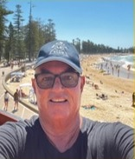 | #117 – 16 March 2023 – Indian Spirituality through a Christian’s eye” – Mr. Paul Bailey https://www.youtube.com/watch?v=l5CPAi5YNEI  Owner, Northern Beaches Accountants, Member of: Institute of Public Accountants, Manly Life Saving Club, Warringah Masters Swimming Club, Captain – Patrol 5 at Manly LSC, Spiritual Wayfarer.
Dr. Hameedha Banu  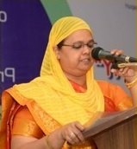 | #101 – 24 November 2022 – Light of Mohiddeen Abdul Khader Jeelani – Dr. Hameedha Banu  http://www.youtube.com/watch?v=QnJAu8lvkMc  #106 – 29 December 2022 – Khwaja Moinuddin Chisti – Dr. Hameedha Banu https://www.youtube.com/watch?v=miSESVbhP9c  Dr. Hameedha Banu, B.Sc., M.A., M.Ed., M.Phil., Ph.D  Principal, Sri Vijay Vidyalaya College of Arts and Science, Dharmapuri, India. 30 years of teaching experience  Received many awards including “The Best Principal”award  Poet, Published two volumes of poems in Tamil  NLP Trainer,
Mr. Pankaj Bharadia | #13 - 18 March 2021 - Nature of Soul - Who am I not?- Mr. Pankaj Bharadia  https://www.youtube.com/watch?v=zLE37sYED8c
Ms. Uma Bharathy  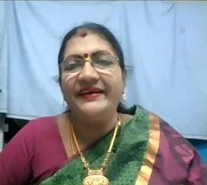 | #79 – 23 June 2022 – Tamil Poet Subramaniya Bharathy – Ms. Uma Bharathy https://youtu.be/SMr6KwEjw1k  Ms. Uma Bharathy is a great granddaughter the great Tamil Poet Subramaniya Bharthy. She lives in Tamil Nadu India. Her great grandfather dedicated his life for social reform – justice, gender equality, human rights etc.  Against caste system he wrote:  [English Translation]  There is no caste system.  It is a sin to divide people on caste basis.  The ones who are really of a superior class are the ones  excelling in being just, wise, educated and loving.  https://en.wikipedia.org/wiki/Subramania_Bharati
Ms Jill Biddington  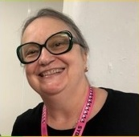 | Jill Biddington – Director, Education and Development The Media, Entertainment & Arts Alliance https://www.youtube.com/live/WrG78kbgdW8  Jill is a union official and educator. She entered the union movement as a rank-and-file member in the finance industry, and was leader of the one of the five unions that amalgamated to form the finance Sector Union. She has also worked for the New South Wales Nurses’ Association, the Liquor, Hospitality and Miscellaneous Workers Union, Unions NSW, and the ACTU Organising Centre. She has a particular interest in the training and development of union leaders and managers specifically around change, development and democratisation for the increased participating of rank and file members. Jill is active in her local community and has an interest in working with migrant workers, opposing racism and exploitation and advocating for better mental health services. She has worked for community organisations, and for international development organisations and is a peace activist. She lives in Sydney.
Mrs. Sunitha Bishan  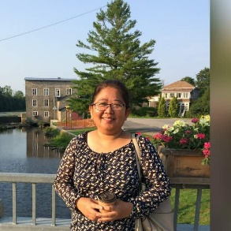 | #21 - 13 May 2021 - Changing the Climate through Compassion - Mrs. Sunitha Bishan https://www.youtube.com/watch?v=6coSX5rko2E  Researcher Mrs. Sunitha Bishan's work in Malaysia and Philippines on The voices of the women living in a raging Climate. This story is part of a regional research on "Building New Constituencies for Women's Sexual and Reproductive Health and Rights (SRHR) and Climate Change.  Sunitha Bishan is passionate about ecology and gender justice. Sunitha has over 20 years of experience in integrating gender in environmental governance. She is currently in Ottawa, Canada. Sunitha believes that feminist views towards mainstreaming gender and ecology in governance are key for a just future. Sunitha holds a Masters degree in Gender and Development as well as Masters in Law in Environmental Governance and Sustainability. She is currently pursuing her doctorate degree.
Ms. Faith Black  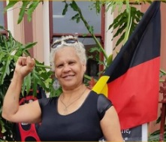 | #61 - 17 February 2022 - A First Nation Woman's view on Global Unity - Ms. Faith Black  http://www.youtube.com/watch?v=g5IoeFpPuJg  Ms. Faith Black is a descendant of the Meriam people of Mer island and Batjala people of Fraser island. She is an activist mostly involved with the efforts to end First Nation Deaths in Custody. She is a Montessori Teacher. She is a mother of five healthy amazing sons.
Mr. Biswadeb Chakraborty  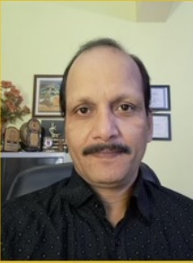 | #92 – 22 September 2022 - Unity in Diversity - Mr. Biswadeb Chakraborty http://www.youtube.com/watch?v=zN0vMnmeYlY  Biswadeb Chakraborty was born and raised in a rich spiritual tradition in a yogi family. From the age of 15, he started organizing traditional musical events in local communities. He has deep respect for all religious and ethnical communities. Biswadeb plays a very active role in or mobilizing and organizing peacebuilding activities with small and large groups specially using his musical talent to harness the highest vision that promote the Principles of creating cultures of Peace. Last 15 years Biswadeb is working as Indian National Coordinator of the United Religions Initiative – a global grassroots interfaith network that cultivates peace and justice by engaging people to bridge religious and cultural differences and work together for the good of their communities and the world.
Ms. Samantha Tom Cherian  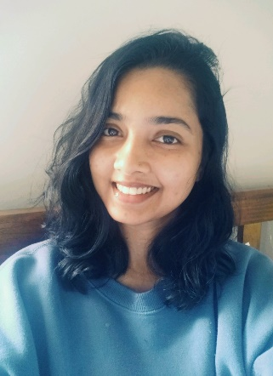 | #71 – 28 April 2022 - Youth PoWR and Inter-religious dialogue - Ms. Samantha Tom Cherian http://www.youtube.com/watch?v=SAVflRiG6mI  Samantha is the Youth & Networking Coordinator of the Columban Centre for Christian-Muslim Relations (CCCMR). Samantha’s primary responsibility is promoting interfaith relations among youth, especially Christians and Muslims. One of her major tasks will be coordinating Youth PoWR (Parliament of the World’s Religions). Upon graduating from the University of Sydney in 2020 with a master’s degree in International Security, Samantha went on to work at STARTTS as a Community Development Evaluation Assistant. Her primary interests include conflict resolution mediation, women empowerment and international humanitarian law. As a Youth & Networking Coordinator, Samantha hopes to embody the values of CCCMR and promote an environment of acceptance, understanding, empathy and spirituality.
Ms. Kim Chong  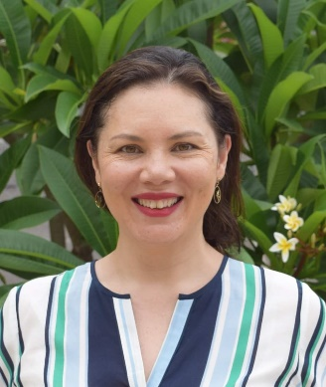 | #45 - 28 October 2021 - Unity in a COVID World - Ms Kim Chong https://www.youtube.com/watch?v=Zj8hMaChSQc  Kim Chong is the Media & Community Liaison at the Columban Centre for Christian-Muslim Relations. Bringing skills from a career in print media, Kim is primarily responsible for producing their quarterly newsletter, Bridges, contributes to social media, develops promotional material for interfaith events, and general communications. As Community Liaison, Kim promotes the interreligious apostolate to the Christian community and grows relations with women of other faiths. She is a graduate of sociology and women’s studies from UNSW, where her research interests focussed on the lived experiences of dialogue in everyday life. She is also a mother of two young daughters.
Venerable Thubten Chökyi  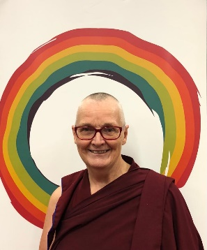 | #57- 20 January 2022 - Climate Change - A Compassionate Response and Universal Responsibility - Ven. Thubten Chökyi  Venerable Thubten Chökyi was ordained as a Buddhist nun in the Tibetan tradition in 2006. She is the chair of the Australian Sangha Association and the Director of Liberation Prison Project and resident teacher at Hayagriva Buddhist Centre and Tara Meditation Centre in WA.  After ordination, Venerable Chokyi was the Spiritual Program Coordinator at the FPMT Centre (Foundation for the Preservation of the Mahayana Tradition) in Sydney, Vajrayana Institute, for 10 years and in 2018 was appointed the resident western teacher at Chenrezig Institute, an FPMT Centre in Queensland. Venerable Chokyi was teaching the FPMT foundation course Discovering Buddhism, a two-year program which gives students a solid foundation in the teachings and practice of Tibetan Mahayana Buddhism  Prior to ordination she was academic coordinator of Indigenous Studies at the University of NSW and worked in the arts sector for over 20 years.
Mr Rajkumar Damodaran  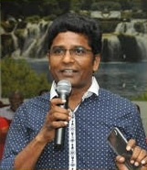 | #120 – 6 April 2023 – Swami Vivekananda – Mr Rajkumar Damodaran https://www.youtube.com/live/1gNsByoSxVk?feature=share  ...studied B.Sc(Agricultural Science) in TamilNadu Agricultural University (TNAU), COIMBATORE... worked in Agri Marketing Field for 2 years... then, moved to Chennai... joined computer science courses & training in HCL Technologies, CHENNAI... Later, joined as Tech Support in HCL, Chennai... worked there for 11 years... came back to hometown (Thiagathurukam) in 2016... currently engaging in cultural and social activities through Tamil Society... Lions Club, Rotary Club and other organisations...
Tracy De Geer  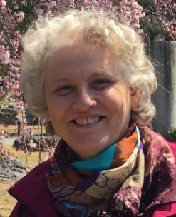 | #2 - 26 November 2020 – Collective Wellbeing – Tracy De Geer  #16 - 8 April 2021 - The Uluru Statement (Australian Indigenous People)- Ms. Tracy De Geer https://www.youtube.com/watch?v=IwT0vAVmg18  #73 – 12 May 2022 – The Uluru Statement – Tracy De Geer  http://www.youtube.com/watch?v=8q3CIfezxmw  #111 - 2 February 2023 - Wellbeing – Tracy De Geer https://www.youtube.com/watch?v=Aa6tlzcg7v4  #123 – 27 April 2023 – Justice – Ms Tracy De Geer https://www.youtube.com/live/gJ0y0Qe558k?feature=share  Tracy DeGeer spent nearly 50 years of researching multi faith ways of being and learning; as well contributing to creating more sustainable living for all on our planet. After 40 years of using herbs including 20 years in various clinics she wrote a book called Sustainable Wellbeing. She has a Bachelor of Health Science (Com) Health Science Charles Sturt University. She has been involved with the Women's Reconciliation Network for 25 years helping to break the silencing of Aboriginal and Torres Strait Islanders' experience.  Publications Sustainable Wellbeing Balboa Press.  She is a mother of 5 children and 5 grandchildren.  https://healthfoundations.com.au/about/  Volunteer to support the people's movement as initiated in the Uluru Statement from the Heart.
Mr Subramaniam Devado  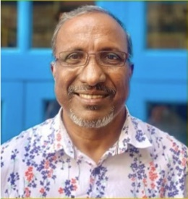 | #75 – 26 May 2022 – Meditation- A Baha’i Perspective –  Mr. Subramaniam Devado  https://www.youtube.com/watch?v=LbrmdGweqiQ  Mr. Subramaniam Devado is from Malaysia. He worked with Malaysian Air Force and recently retired as an aircraft engineering instructor. He has been a Baha'i for more than 50 years, the only Baha'i from his Hindu family of 7 siblings. He is married and they have 4 grown up children.
Mr Colin Dibdin  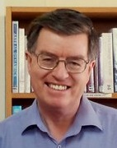 | # 15a – 1 April 2021 – The Attraction of Islam (presentation) – Mr Colin Dibdin https://www.youtube.com/watch?v=pElZE0ZOx5M  # 15b – 1 April 2021 – The Attraction of Islam (discussion)- Mr Colin Dibdin https://www.youtube.com/watch?v=SUxD7pnIq9I  #35 – 19 August 2021 – When Aliens Meet – Mr Colin Dibdin https://www.youtube.com/watch?v=fC_R_RnAOfU  #80 – 30 June 2022 – The Recurring Proof of God – Mr Colin Dibdin https://youtu.be/Fx21Z8nPFDQ  #84 - 28 July 2022 - Extraordinary Initiatives in Interfaith Dialogue - Colin Dibdin https://www.youtube.com/watch?v=J8nX4MO9w-I  #125 – 11 May 2023 – Is a leap of faith necessary? – Mr Colin Dibdin https://www.youtube.com/live/9xqqfFHChMo?feature=share  Colin Dibdin lives in Sydney. He has a Bachelor of Arts majoring in political science and philosophy. He worked in Air Traffic Services for 22 years and now assists the Baha'i community in an administrative role. He is married to Yung and they have two adult children, Danny and Gaby, who are teachers. In his free time Colin participates in the Baha’i Institute process which he sees as the most effective means for transforming himself and society. His other passions include private flying and making interfaith connections.
Ms. Sacha Evans  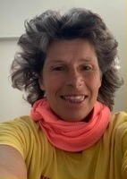 | #95 - 13 October 2022 - How our personality structures are related to spiritual growth - Ms. Sacha Evans http://www.youtube.com/watch?v=5EVQMShRoHo  Ms. Sacha Evans: Personal Coach, Hypnotherapist, NLP trainer, Surfer.
Fr. Michael Fallon MSC  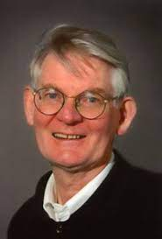 | #58 - 27 January 2022 - Jesus as Portrayed in the New Testament: Divine Love in a Human Heart - Fr. Michael Fallon  Father Michael Fallon is a Missionary of the Sacred Heart based at Kensington in Sydney. Since his ordination in 1961 his ministry has been largely devoted to teaching. He has published commentaries on all of the Books of the Old and New Testaments and a 'Companion to the Catechism', a Reflection on the Psalms, 'Praying the Psalms with Jesus', and an Introduction to the Old Testament. https://www.catholicweekly.com.au/author/fr-michael-fallon-msc/
Dr Afsoon Fanaiyan  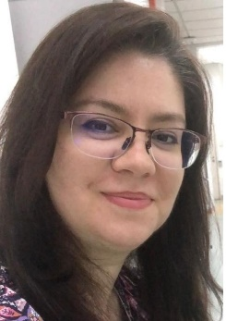 | #116 - 9 March 2023 - The Role of Education in Creating and Sustaining Unity - Dr Afsoon Fanaiyan. https://www.youtube.com/watch?v=B2yLRekw_QA  Dr Afsoon Fanaiyan has started teaching while she was a high school senior. Her first teaching experience was as a volunteer to teach computer science to housewives who wished to get employed in an office. This set her career path into teaching and education.  She has done her masters degree in educational psychology in Iran. While she had an interest in research about post war education and education for peace , she gained hands on experience with junior youth empowerment program. Later on she traveled within the country to train the trainers (animators) for the same program. To gain more experience on social economic development projects she traveled to Malaysia. Fascinated by the Malaysian multiculturalism, she later conducted her PhD research in multiculturalism in school counseling within Malaysian schools.  She has been teaching and training youths both within and outside of the school setting for 25 years now. She also has been providing school counseling to high school students through which she applied the concepts of multiculturalism with youths.  She has developed curriculum for social intelligence training as a school subject for secondary and primary students, as well as writing and illustrating a series of books for children . The first book of the series has published in 2021.  To her, teaching youth and children is not a qualification nor a career path; it’s a calling. Her approach to teaching is inspired by Baháʼu'lláh, the founder of the Baháʼí Faith: "Regard man as a mine rich in gems of inestimable value. Education can, alone, cause it to reveal its treasures, and enable mankind to benefit therefrom."
Dr. Barbara Ferguson OAM  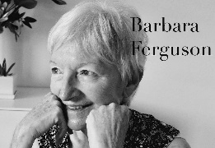 | #19 - 29 April 2021 - Congo Pygmy Program - Dr. Barbara Ferguson OAM https://www.youtube.com/watch?v=i107GaCNoCc  Dr. Barbara Ferguson OAM - Next presenter  Barbara Ferguson, OAM, PhD, Teacher, Social Worker, Author  Barbara has PhD in Psychology and was lecturer at University of Hawaii, University of California and the University of New South Wales. She was working with the Pygmies in the Congo, and with victims of war in Cambodia and South Vietnam. She wrote the book: Rain in My Heart: Memories of Children and War in South Vietnam.  In 1988 she set up a Cross-cultural Social Work Education Centre, in 1994 set up a Postgraduate Program in International Social Development and in 2001-2 set up Centre for Refugee Research.  In 2004 she received Medal in the Order of Australia for her work with refugees, immigrants, and international students.
Ms. Angela Finn  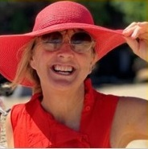 | #89 – 1 September 2022 – A Personal Perspective on Service - Ms. Angela Finn http://www.youtube.com/watch?v=IglD6Zl2jyY  Ms. Angela Finn is a Marriage Celebrant. She is Sydney born and raised in the 60s, 70s & 80s. She has been married for 33 years, with 3 adult kids.  Her career background is diverse – communications, marketing, education, and performance.
Ms. Emily Frances  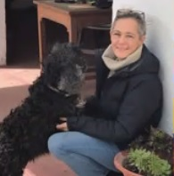 | #68 – 7 April 2022 – Living with Love for Animal Liberation – Ms. Emily Frances  http://www.youtube.com/watch?v=8cQPGK-iSPQ  Ms. Emily Frances is from UK now living in Menorca, Spain. She has an enthusiasm for compassionate and sustainable living. She has a blog, where you will find recipes and articles about lifestyle and wellness along with informative articles advocating human, environmental, and animal justice. She is known as Ethical Emily in the cyber space.  https://ethicalemily.com/
Mr. Ran Fuchs  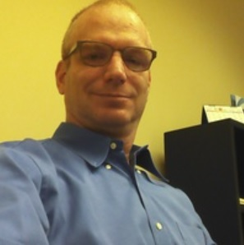 | #63 – 3 March 2022 – Zen Koanic way of resolving ambiguities in the Bible – Mr. Ran Fuchs  Mr. Ran Fuchs grew up in Jerusalem absorbed by history, the Hebrew Bible, and the connection between them. Years of discussing the Bible with people of all cultures and religions made him realise the value of understanding it in its original language and wants to share this value with those who cannot read Hebrew but only familiar with it through the various translations.  He was a mathematician, and ex-CEO of fintech company, and now, since retirement, he devotes himself to understanding the Bible, teaching it. The rest of his time he spends on his passion for photography. You can see his Bible site here: https://hebrew-bible.net/ and his photography site here: https://www.ranfuchs.com
Pravrajika Gayatriprana  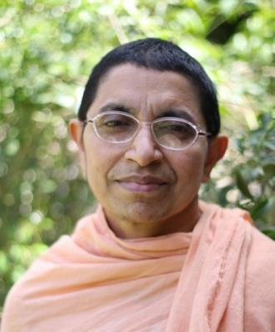 | #41 - 30 September 2021 - Vedanta in the Modern World –Pravrajika Gayatriprana – https://www.youtube.com/watch?v=2JZS48CCL-I  Pravrajika Gayatriprana is a Hindu nun of the Ramakrishna Order. She came to Australia in 1982 with Rev. Pravrajika Ajayaprana Mataji to start the first foreign centre of Sri Sarada Math --- the women's wing of the Ramakrishna Order. She is the President of the Ramakrishna Sarada Vedanta Society of NSW and South Australia.  Pravrajika Gayatriprana gives regular talks on Vedanta on Sundays and also conducts discussion groups on Fridays. She also conducts Meditation Days and Retreats at the Vedanta Hall and also at their retreat centre in Robertson in the Southern Highlands. She regularly travels to Adelaide twice a year and gives lectures and conducts retreats.
Revd Dr David Gill AM  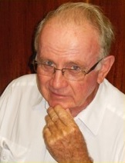 | #113 – 16 February 2023 – Religion’s Struggle: The Love of Power vs the Power of Love – Revd Dr David Gill AM https://www.youtube.com/watch?v=6FRlR-2jivY  Ordained in 1965, David Gill served on the staff of the Australian Student Christian Movement, studied in the USA and Switzerland and worked for 12 years with the World Council of Churches (WCC) in Geneva. He was general secretary of the National Assembly of the Uniting Church in Australia and the National Council of Churches in Australia, before taking on what he says was the best job of the lot: pastor of Kowloon Union Church, Hong Kong. Along the way he has visited over 60 countries, sat through more meetings than he cares to remember, been closely involved with the Christian Conference of Asia, served on the Joint Working Group between the WCC and the Roman Catholic Church and helped promote relations between Christians and people of other faiths.
Mr. Val Girilovitch  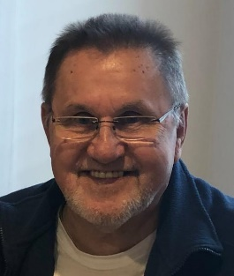 | #70 – 21 April 2022 - Benefits of Tithing – Mr. Val Girilovitch http://www.youtube.com/watch?v=_mYLD8OujHc  Mr. Val Girilovitch is a businessman and community development worker. He has travelled the world advocating for self-help programs for prisoners, drug dependent people and the mentally ill. He is currently involved in producing a documentary and writing a book about tithing which he believes can be a solution to world poverty and self-development. He lives in Sydney NSW.
Mr. Karthikeyan Govindarajan  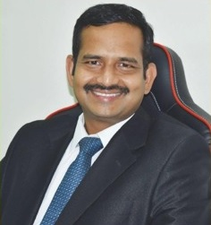 | #129 – 8 June 2023 – ThiruValluvar & Peace – Mr. Karthikeyan Govindarajan https://www.youtube.com/live/0hrCqRJQVZA?feature=share  Mr. Karthikeyan Govindarajan, Electronics & Communication Engineer. Worked in India & Qatar  Promoter of Thiruvalluvar’s Thirukural  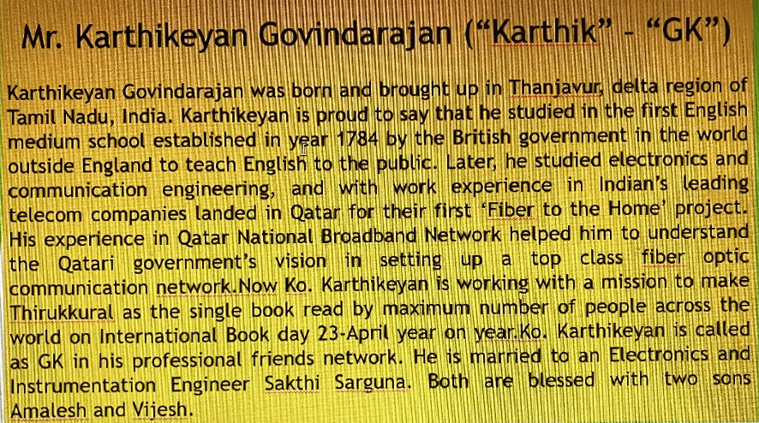
Dr Boris Handal  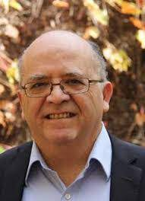 | #38 - 9 September 2021 Religion of The Bab - Dr Boris Handal https://www.youtube.com/watch?v=Nl5lvKZ04ts  Dr Boris Handal is a Professor of Education at the University of Notre Dame Australia. He has taught in schools and universities in South America, Asia and Australia for over thirty-five years. Dr Handal is the author of over 100 publications including several books about the history of the Bahá'í Faith.
Mrs Minoo Hatami  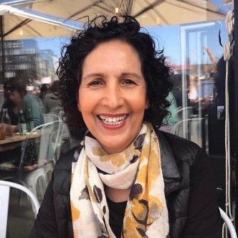 | #77 - 9 June 2022 - Friendship - Mrs Minoo Hatami https://www.youtube.com/watch?v=NGy-cFztoRU  #115 - 2 March 2023 - Consultation - Mrs Minoo Hatami. https://www.youtube.com/live/n-nLYjaSP6w  Relationship Coach (Information from LinkedIn)  My background: I worked as a counsellor and mediator for 15 years, and since 2006 as a certified life and master relationship coach. I have developed and facilitated numerous relationships retreats and workshops for singles and couples over the past 25 years. I have also given presentations at conferences and seminars and published a variety of articles on how to have success relationships.  Through my own challenges, personal growth, and observations of people around me, I have recognised a growing need to achieve an optimum quality in relation to self and others. I view life as a series of learning opportunities to grow and mature. I am passionate about relationships, spiritual growth, and our ecosystem.
Ms. Dot Haynes  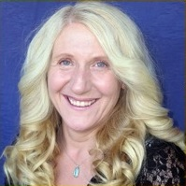 | #99 – 10 November 2022 – Presenter – Difference is a Gift – Ms. Dot Haynes http://www.youtube.com/watch?v=yZTPGiBvvi4  Dot Haynes is all about doing things that will benefit others and especially if it helps to make a difference for the greater good of all people. She is passionate about building community spirit and doing what she can to bring people together irrespective of their backgrounds and differences.  She is an author of two books: “Pretending to be”, “People Matter”  As a new mother she intentionally moved to Doncaster. She has been a Doncaster resident for almost 30 years. Dot has done much to break down barriers between people. This has included working hard for over fifteen years to see the development of a strong Manningham Interfaith Network Inc. www.dothaynes.com.au
Mr. Marc Iseli  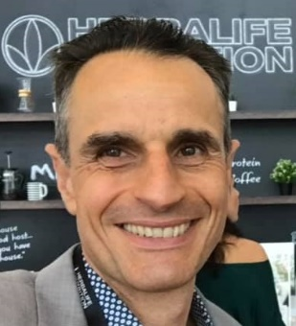 | #104 – 15 December 2022 – Mr. Marc (Marcel) Iseli – The Real Meaning of Christmas: The story of A Fathers Love for His Children – https://youtu.be/YMJ2PqE8OPs  Marc (Marcel) Iseli  - BSc (Bachelor of Science) in Health Sciences and Chiropractic  - Diploma of Christian Ministry  - Deep interest in nutrition, longevity, optimum health and prevention of disease.
Dr Raiz Ismail  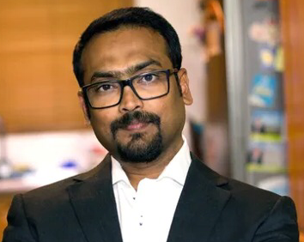 | #66 – 24 March 2022 - Dr Raiz Ismail - Psychological Blind Spot & Xenophobia https://www.youtube.com/watch?v=02BWA5tEFHk  Dr. Raiz ISMAIL is a consultant psychiatrist and a fellow of Royal Australian and New Zealand College of Psychiatrists . He has had his medical education, psychiatric training, teaching experience and career in India, the UK and Australia.  His areas of interest include: depression and bipolar disorder, psychosis, anxiety disorders including panic Disorder, OCD and PTSD, grief and adjustment Disorders. He has a special interest in working with people from culturally and linguistically diverse background. He is from Tamil Nadu, India and speaks Tamil.
Christella Jayawardena  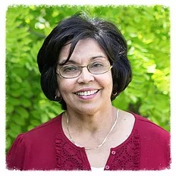 | #28 - 1 July 2021 - Subconscious mind & emotions - Christella Jayawardena https://www.youtube.com/watch?v=sC9Kx_KrImo  Mrs. Christella Jayaewardena was born in Sri Lanka and qualified as a Chartered Accountant; Spent 14 years living and working in Jamaica; Been here in Australia for 30 years; She has two adult children.  Worked with large corporations in Finance and Accounting but now more interested in mind body healing and helping people with natural health. She is a Reiki Master and CTC Master Practitioner.  Christella is an avid researcher of natural health, the mind body connection and latest developments in these areas.
Rev. John Jegasothy  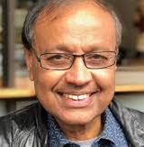 | #4 – 10 December 2020 – Unity - Rev. John Jegasothy  #7 – 4 February 2021 - Human Rights - Rev. John Jegasothy  Bio from https://uniting.church/rev-john-jegasothy/:  After serving for the last six years of his ministry in Srilanka as Chair of the Human Rights organization in Trincomalee and settlement of victim of war John came to Australia on special Humanitarian Vida in 1986, he served in the Uniting Church beginning from Parkes and Shellharbour, Dulwich Hill - Hurlstone Park and Rose Bay - Vaucluse and retired in December 2020. He was Chairperson of Central West Presbytery in the early nineteen nineties.  He has the passion for justice for all and so worked in the area of community development, human rights, justice, advocacy & settlement of asylum seekers and refugees, also provided leadership in multicultural ministry and Christian Spirituality. He is a member of “The Australian Churches Refugee Taskforce”of NCCA.
Pastor Eddy Johnson  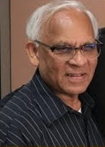 | #86 - 11 August 2022 - The Problem of Evil - Biblical Perspective - Pastor Eddy Johnson https://www.youtube.com/watch?v=NcD-l7EdmFQ  Pastor Eddy Johnson is retired minister and teacher of the Seventh Day Adventist church. He is a Counsellor. He lives in Sydney with his family.  He holds degrees in theology and administration
Mr. R. Kaliamoorthy  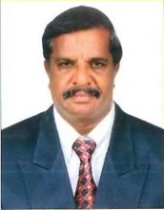 | #103 – 8 December 2022 – Mr. R. Kaliamoorthy - Gandhiji and His Satyagrah – https://www.youtube.com/watch?v=37hZk811bvQ  Indian Oil Corporation Ltd, Central Govt., India. Poet, Writer, Educationist, Freelancer and Social Activist.  Faculty and Counselling for IAS Examinations and give Lectures on IAS Awareness Programme in All India Radio, Karaikal. Committee Member, Indian Red Cross Society, Karaikal.  Author of “A Drizzling from the Heart" anthology of English poems launched in Kindle - Amazon.  Collection of Tamil poems ""Kaliyavin kavithaigal" now getting ready for publishing.
Dr. Reihaniyyih Kassimova  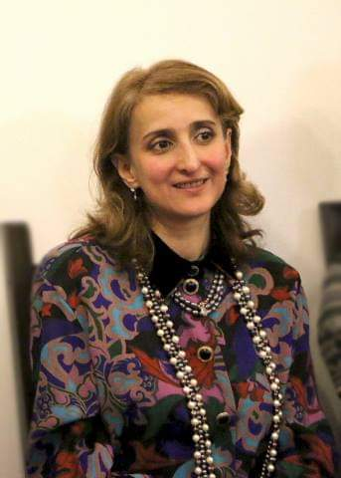 | #50 - 2 December 2021 - Happiness is... - Dr Reihaniyyih Kassimova  #122 - 20 April 2023 - Importance of the Ridvan Festival - Dr. Reihaniyyih Kassimova https://www.youtube.com/live/BF-fiCc-x9I?feature=share  Dr. Reihaniyyih Ismulla Kyzy Kassimova is a third generation Baha’i starting from the time of ‘Abdu’l-Baha’, successor of Baha’u’llah, the Prophet Founder of the Baha’i Faith.  Reihaniyyih is a mother of four children and lives in Russia.  Her professional interests are, origin and search of diamondiferous rocks, gemmology, synthesised semi-conductors, petroleum searching etc. She is an expert in gemmology and oil-gas deposits. She is a Professor at Moscow State University named and Russian State Geology and Exploration University, and author of 40 scientific works and a fairy-tale “Flute”.
Dr Yogakanthi Kathiresu  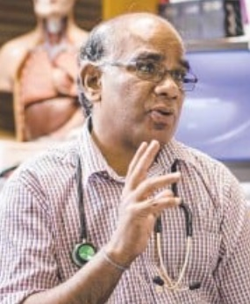 | #64 – 10 March 2022 – A View on Indigenous Health - Dr Yogakanthi Kathiresu  https://www.youtube.com/watch?v=k1OCYyQEecY  Dr Yogakanthi (Kanthi) Kathiresu from Sri Lanka. He is a registered General Practitioner (GP). He has been working with Aboriginal and Torres Strait Islanders patients for more than 20 years and he is passionate about improving their quality of life. He is currently working with Townsville aboriginal and islander health services.  Kanthi acknowledges that indigenous people are dealing with complex psychological trauma and chronic pain and therefore he dedicates most of his time helping them to overcome their challenges.  He is married and has a son who is a young doctor in Melbourne.
Mr Neil Khare | #31 - 22 July 2021 - Power of Being - Mr Neil Khare https://www.youtube.com/watch?v=yk0Y3tXdgKk  Neil Khare is an actor, playwright, director. Neil was born in Kolkata, India and migrated to Sydney in 1996. From childhood, his extra-curricular participation in school plays brought him to the realization of his love for the craft. His repertoire includes many plays such as Hamlet, midsummer night’s dream, Couplet of Bengal etc; He was involved in the Imagine Festival and has worked with a few film producers/directors.  Sucharita - Her Story””, is a play he directed, will be performed on 13 August at The Gumbramorra Hall, Marrickville (https://stayhappening.com/e/sucharita-her-story-E3LUSFK32UPS  He claims his involvement in theatre “has given me opportunities to explore the complexities of life, it is through sheer determination and passion that one can achieve fulfilment, it is how we travel, it’s not the destination but the journey that matters.’’  I was born in Kolkata, India but migrated to Sydney in 1996. From childhood, my extra-curricular participation in school plays brought me to the realization of my love for the craft. Fuelled by this passion for theatre, I enrolled with NIDA and completed the Screen Actors Course. My repertoire includes a few plays such as Hamlet, midsummer nights dream, Couplet of Bengal, neighbours, Tartuffe, Jekyll and Hyde, Hands of God and Divine Intervention ,Crucible, Forbidden Territory and Bonds of Love. I have been involved in the Imagine Festival and have worked with names such as Maggi Scott, Shiyan Zheng, Debbie Smith Uma Kali, Alex Broun, Dan Graham and Visakesa Chandrasekaram.  I have had the great honor of directing plays like Haus, Forbidden and a short play called Kamasutra for the short and sweet festival. Cry Havoc is another wonderful courageous piece giving me an opportunity to explore the complexities of life, it is through sheer determination and passion that one can achieve fulfilment, it is how we travel it’s not the destination but the journey that matters.
Tahira Amir Sultan Khan | #48 - 18 November 2021 - Becoming the New Human - Ms Tahira Amir Sultan Khan  Ms. Tahira Amir Sultan Khan is an Author, Speaker, Technologist and Spiritual Futurist.  Tahira holds a double major Bachelor's Degree in Computer Science and Mathematics (UWA) and an MBA (International Business) from Melbourne University, with high distinctions. She was the first female President of Mobile Alliance Singapore. After 20 years in technology as an Advisor and Consultant to international governments, she made the big switch to becoming a full-time author.  Through her life journey, she transformed to become a Renaissance woman, who was able to masterfully interleave spirituality, philosophy, geometry, quantum physics, symbolism, biology, ancient wisdom, poetry, literature and art.  She received many awards including The ASEAN Lady of Excellence (2017), Asia Pacific Golden Brand Award (2018).  In 2019, she founded the pioneering Golden Door – for Justice through Truth & Integrity of the Written Word. ----from https://www.tahiraamirsultankhan.com/?r_done=1
Ms. Anisha Lakhani  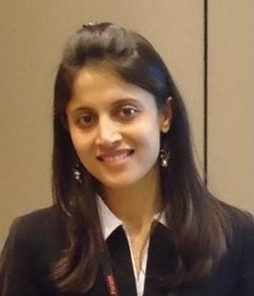 | #91 – 15 September 2022 – Scriptural Reasoning – Ms. Anisha Lakhani http://www.youtube.com/watch?v=_iue1zHbJG0  (Thought Leader, Education Manager, Learning Strategist)  Anisha Lakhani is an emerging leader and an educator who has adopted a variety of careers from a Business Warehousing Consultant to becoming a passionate educator. She started her career in the field of IT and then completed MBA in Finance and, then in UK, Double Masters in Teaching and Education. She has now been in the field of education since last 11 years as a teacher, mentor and education manager. Anisha loves traveling having visited more than 25 countries in relation to her work, educational trips, and conferences, workshops, and youth camps. She is interested in interfaith relations and has completed Cambridge Interfaith relations summer course last year. Anisha is originally from Nashik, India, and now living in Sydney.
Mr. Lee Tiew Kiang (TK Lee)  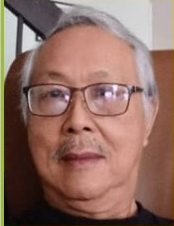 | #112 - 9 February 2023 - The Promised Day is Come - Mr. Lee Tiew Kiang (TK Lee) https://www.youtube.com/watch?v=Ae_D1X5q1bw  Mr. Lee Tiew Kiang from Malaysia is Retired human resource manager. He married to a lovely lass he met in Kenya some 46 years ago. Proud grandfather with 3 children and 6 grandchildren.
Mr. David Levick  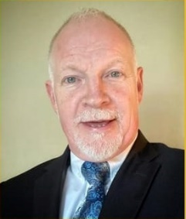 | #74 - 9 May 2022 - Our Identity and Social Issues - Mr. David Levick https://www.youtube.com/watch?v=fV7D-caLzCw  Mr. David Levick, an academic, a Bahá’í for 35 years, who has been, at various times, a print media journalist; a student of complexity science and its application to organisations and businesses; a logician and a promoter of the application of logic for organisational improvement and project delivery; and a lover of humanity and the natural world.He has contributed to the book ‘’Building Sustainable Communities: Environmental Justice & Global Citizenship’’In this session he will explore the role of our identity and self-worth in overcoming social issues.
Dr. Ashit Mohan Maitra  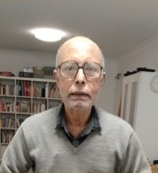 | #88 - 25 August 2022 - A secular approach to spirituality from a Hindu perspective - Dr. Ashit Mohan Maitra https://www.youtube.com/watch?v=KXZheJNIaUs  Dr. Ashit Maitra is currently the Hindu Chaplain at Sydney University and at UTS. Professionally retired as a researcher (Principal Research Scientist at CSIRO) and academic (Senior Lecturer at PNG Unitech.
Mr Palitha Manchanayake  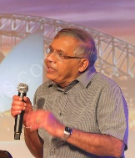 | #29 - 8 July 2021 - Buddha Dhamma - Mr Palitha Manchanayake https://www.youtube.com/watch?v=qKMpnJMVMFk  Mr. Palitha Manchanayake was an engineer in Sri Lanka at Irrigation Dept. and then an Assistant Director of Mahaweli Authority. In Australia he was a Hydrologist at Bureau of Meteorology, Sydney forecasting flood in NSW.  He has published many books including two on Buddha Dhamma namely ‘I-ing and My-ing’, and ‘Naama-Rupa’ (meaning Name-Form) and some on technical subjects.
Mr Rod Markham | #11 - 4 March 2021 - International Language - Mr Rod Markham  #20 - 6 May 2021 - International Auxiliary Language - Mr Rod Markham  Notes by Colin Dibdin (friend of Rod):  Rod Markham is a school teacher, and is passionate about the Bahá'í principle of “An International Auxiliary Language”. In his presentation Rod stated that “it will be up to the parliaments of the world to choose such a language,…”, either from existing languages or invented. Rod has explored some possibilities and developed some concepts by means of what he refers to as “Avash Script”.
Ms Gabrielle McGuire  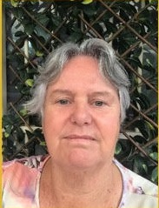 | #62 – 24 February 2022 – Social Action for Unity – Ms.Gabrielle McGuire  Ms. Gabrielle McGuire is currently semi-retired, living and working an organic fig orchard in Mudgee, NSW  Surveyor by trade, she worked on some very big and remote projects in Western Australia and Northern Territory in construction and mining industries  Due to family commitments she left surveying, She built specially designed indoor heated swim school and taught children to swim, which worked well with raising her kids.  Later she travelled to remote villages with her daughters in the Solomon Islands, building rudimentary preschool, setting up women’s groups and micro economic projects for them, as well as a few men’s micro economic projects. She also ran junior youth workshops and children’s programs..  She lived in the communities in Kimberley, Western Australia and worked closely with the locals. She developed a greater understanding of the deep trauma currently been experienced that non-indigenous folks are causing.
Mr. Vasu Mohan  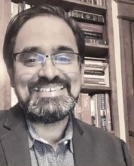 | #96 – 20 October 2022 – Bharathi, Tagore & ‘Abdu’l-Baha – Mr. Vasu Mohan http://www.youtube.com/watch?v=fXFnE2fgDmk  Vasu Mohan has been working on democracy, governance and human rights work in Asia. His work focuses on political, social and legal empowerment of women and vulnerable groups.  He has also served in various voluntary capacities including as Member of the Board of Directors for the Tahirih Justice Center, an NGO to protect immigrant women and girls seeking justice  Mohan is co-author of four publications: (1) Electoral Rights of Environmentally Displaced People, (2) Gender Equality and Election Management Bodies: A Best Practices Guide, (3) Sehr: A New Dawn Breaks, (on Muslim Women's Initiative in India), and (4) Countering Hate Speech in Elections. He is working on a translation of vignettes from the history of his native Sri Lanka from Tamil into English.  He is a Bharatha Natya dancer too.
Dr Prabu Nadaraja | #24 - 3 June 2021 - Shaping the future together - Dr Prabu Nadaraja https://www.youtube.com/watch?v=YV8xrzBEOYc  Notes from Siva Peri’s introduction to the talk:  Dr Prabu Nadaraja is in Sri Lanka. Prabu started an organisation Suadi (?), meaning ‘footprint’, giving hope and support to others who are vulnerable and trying to help people in various ways including teaching English, through the Internet, to many in Sri Lanka where the need is great.
Mr Nandy Nanthivarman  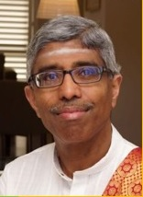 | #121 - 13 April 2023 - An Introduction to Saiva Philosophy - Mr.Nandy Nanthivarman https://www.youtube.com/live/IMFd6rro7YE?feature=share  Mr.Nandy Nanthivarman is a Chartered Accountant with extensive experience in commerce, accounting and finance - gained from the distribution, manufacturing, transportation and construction sectors. He has led a number of fundraising, acquisitions and subsequent integration projects.  Nandy was previously CFO of Claim Central Consolidated for a period of seven years before becoming Non-Executive Director.  His past positions include Finance Director, Gate Gourmet Australia and Chief Financial Officer, AirRoad Group. He also currently sits on the board of Inner Flame, a charity that helps ignite the inner potential of youngsters who are less fortunate.
Ganzibra Professor Brikha Nasoraia  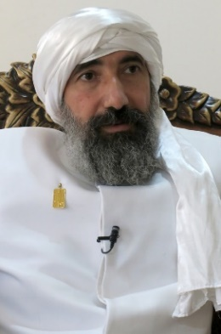 | #42 - 7 October 2021 - The Mandaean Religion - Prof Brika Nasoraia https://www.youtube.com/watch?v=k4-sIC8TJ0o  Ganzibra Professor Brikha Nasoraia is the High Priest of the Mandaens in Australia, and the president of the International Mandaean Nasoraean Supreme Council and the Nasoraean Mandaean Association.  He is a Professor of Arabic, Semitics and History of Religions. He is working at Mardin Artuklu University and at the University of Sydney (Department of Studies in Religion). He is also a researcher at the Department of History and Archaeology, Macquarie University. Up to present, he has obtained four Doctorates in various fields of humanities, and just about to submit the fifth one. He is a distinguished Australian philosopher, academic, artist, social activist, author, public intellectual, and prominent leader. He is credited with having brought coherence to the fields of Mandaeism and Gnosticism. He is the world leader of Nasoraean Mandaeans. He is a founder of the Mandaic and Semitic Program for the Postgraduate Studies at Baghdad University.  Professor Nasoraia is an archaeologist with more than 17 years of fieldwork experience. He uses ancient text and archaeological evidence to explore the ancient history of religion as well as the religious cultures of the ancient Mesopotamia. Professor Nasoraia is also a Buddhist scholar and an international advisor of World Yoga Foundation. Furthermore, Professor Nasoraia contributes substantially to the Middle and Near Eastern Studies. His teachings analyse and explain the dynamics of religion, culture and political economy in the contemporary Middle East. This has been transformed freshly to a special new book (in press) entitled: Speaking the “Unspeakable”: Understanding Changes and Transformation in the Middle East.  He won prizes in many subjects, including Arabic and Semitic languages and cultures, Middle and Near Eastern studies, political economy, human rights, logic, archaeology, religious and indigenous studies. He delivers many public lectures on ‘the dynamic of Healings’ and ‘the Nature of (Spiritual) Mind.’  "Mandaean Anthem" - the first Studio Anthem- Music Product for our Mandaean Community. https://youtu.be/gZpFFM3MNKg
Mr Graham Nicholson | #8 – 11 February 2021 – Global Justice - Mr Graham Nicholson  Information from https://supremecourt.nt.gov.au/  Graham Nicholson is Australia's leading expert on the constitutional structure and history of the self-governing Northern Territory. … Following the grant of self-government, he was appointed as the new body politic's first Crown Solicitor. Mr Nicholson subsequently held appointment as Crown Counsel for the Territory for almost 20 years…  … In addition to his legal professional duties, Mr Nicholson has also been active as a researcher and academic. …Mr Nicholson was also a lecturer in Constitutional Law for many years at the Charles Darwin University, and subsequently an Adjunct Professor with the institution. .
Mrs. V. Olagammal  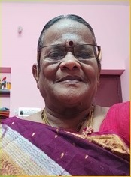 | #94 – 6 October 2022 – The Role of Teachers is Shaping the World - Mrs. V. Olagammal http://www.youtube.com/watch?v=Glu_xZdbEeU  Mrs. V. Olagammal is a retired English Teacher from Tamil Nadu, India. She has triple Masters in Education, English and Hindi. She is actively involved in social, cultural activities. She is creative and writes her own poems is Tamil and English and sings as well.
Mr Edward O’Toole  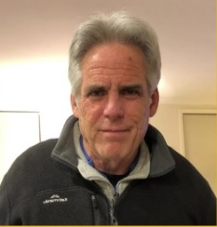 | #67 – 31 March 2022 – Water – in an encounter of Jesus – Mr. Edward O’Toole  http://www.youtube.com/watch?v=jZRvap3YcNM  Edward O’Toole is a retired teacher. He lives in Croydon Park, NSW, Australia. He is married to Maria and has 2 children and 3 grandchildren
Mr. Paramasamy Panchadcharam  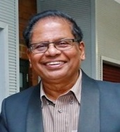 | #87 – 18 August 2022 – “OM” Sound In the Universe and The Faith on Earth – Mr. Paramasamy Panchadcharam http://www.youtube.com/watch?v=cr0kI1ySkb4  Mr. Paramasamy Panchadcharam is a retired Chartered Electrical Engineer from Sri Lanka and lives in Sydney. He had his Bachelor’s degree from Sri Lanka and Master’s degree from UTS, Sydney. He was a Project Manager with Integral Energy.  He is actively involved in Tamil community and Saiva (Hindu) activities. He is the current President of Tamil Senior Citizens Association in Sydney and past president of Auburn Tamil Society. He is interested in Astrology. He has written few books in Tamil about his Pilgrimage to Holy Sites in India and about Astrology. One of the books is translated into English.  He has received honorary titles for his endeavours in religious and astrological fields.
Mr Ana Pararajasingham  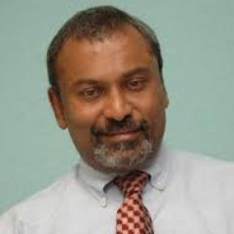 | #47 - 11 November 2021 - My Spiritual Journey - Mr Ana Pararajasingham https://www.youtube.com/watch?v=h5m1WJ_aWwg  Ana Pararajasingham believes that Truth is many splendored and is to be found in all religions and philosophies. His presentation is titled ‘My Journey’ explaining how his inner journey had influenced his outer journey.  He is currently working with refugees and asylum seekers.  He is the author of the book Sri Lanka A Victor’s Peace exploring the developments in the decade following the end of the civil war in Sri Lanka. The book is a is a collection of articles by him published in international journals as events unfolded following the end of Sri Lanka’s ‘civil war’
Ms. Aashi Parikh  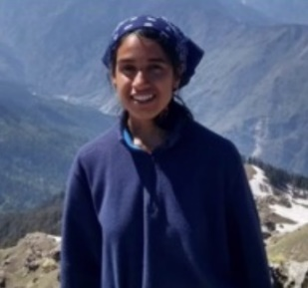 | #76 – 2 June 2022 – Our Interactions with Beauty – Ms. Aashi Parikh  http://www.youtube.com/watch?v=PU6MOm6xTew  Ms. Aashi Parikh was born and mostly raised in India. Ever since she was a child, she had a deep love for animals and found herself more comfortable and at home outdoors and surrounded by nature. Now she lives in Sydney, and is pursuing a PhD as a marine biologist. She is excited to delve into this topic of " Our Interactions with Beauty " with everyone, and to explore the different forms of beauty which attract our human hearts.
Mr Lawrence Pathinather | #12 - 11 March 2021 - Meaning of 'God Bless You' - Mr Lawrence Pathinather  From Facebook:  Studied at University of Peradeniya  Went to St. Patrick's College, Jaffna, Sri Lanka  Lives in Sydney, Australia  From Sillalai
Mr. Ben Perkins  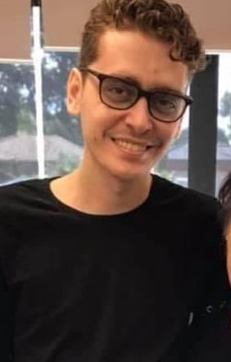 | #23 - 27 May 2021 - Practical guidance on achieving unity in diversity- Mr. Ben Perkins https://www.youtube.com/watch?v=KQWH7GxMB_w  Mr. Ben Perkins has completed undergraduate studies in the field of chemistry and briefly worked in administration and business management. "While he is still establishing himself professionally his primary passion is studying Baha’i history and what the Baha’i framework has to offer in terms of social action initiatives of the wider community."
Dr David Perkins | #27 - 24 June 2021 - Oneness of Humanity: a Scientific Perspective - Dr David Perkins https://www.youtube.com/watch?v=G4Faf8eEpFY  Dr. David Perkins holds a PhD in chemistry, specifically in Supramolecular Architecture and has worked for the Victor Chang Heart Institute designing molecules to mitigate heart pump function in blood pressure patients. In his undergraduate degree he did a double major in chemistry, a major in physics and a major in geology which constituted a 100% overload in his final year and still managed to win the University Medal. He currently teaches mathematics to high school students.
Mr. Riaz Peter  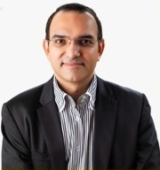 | #82- 14 July 2022 –Fear, Self & the Higher Nature–Mr. Riaz Peter  http://www.youtube.com/watch?v=DkPp9zno_Qc  Mr. Riaz Peter lives in Brisbane, Australia.  He is a Life Coach and he focusses on using spiritual principles and teachings in helping his clients find happiness and success.  The focus of his presentation is on Fear, Self & the Higher Nature and followed by breathing meditation.
Ms. Zubeda Raihman  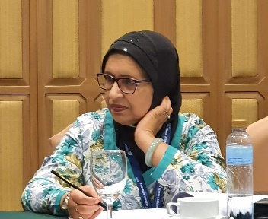 | #22 - 20 May 2021 - Islam, Religion of Unity and Peace - Ms. Zubeda Raihman https://www.youtube.com/watch?v=dC3vpggiq_k  Zubeda Raihman emigrated from Fiji 32 years ago after experiencing several bloodless military coups.  She has 3 adult children and lives in Sydney.  She is an accounting, leadership and management graduate; she holds a CPA membership and is a Justice of Peace in NSW.  Zubeda has worked in the Accounting and Finance field for several decades.  Currently she is the President of Muslim Women's National Network of Australia, Inc. (MWNNA), President, Australian Women's Coalition (AWC), Convenor, Women's Interfaith Network (WIN), Director/Treasurer, Together for Humanity (TFH), Exec Member, Faith Ecology Network (FEN), Treasurer Pan Pacific South East Asia Women's Association (PPSEAWA) and Organizing member, Women's Interfaith in Shire of Hornsby (WISH).  She is passionate about demystifying the preaching of Islam as a Religion that promotes peace and unity. She is neither a scholar nor holds extremist cultural views in the interpretations of Islamic preaching. She is an ardent supporter of Interfaith dialogue and forging bonds with the people of other religions of the world as she believes in the one and the only Creator of our Universe.
Muthiah Ramanathan  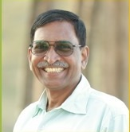 | #110 – 26 January 2023 – Unity in Diversity – Muthiah Ramanathan.  https://youtu.be/EvoMip6l9Rs  Mr. Muthiah Ramanathan M.S(Psychotherapy)  Founder-Mind Dynamics Center, Author, Corporate Trainer, NLP Trainer  In well over 30 years, he has presented Training programs on all aspects of Personality development to well over 1 lakh people in English and Tamil, all over India. He has also presented in-house training programs in Malaysia and Sri Lanka; and online training programs in USA. More than 1000 people from 50 different countries have taken his course “Transactional Analysis A to Z – In a Nutshell”  He has also written 2 best-seller books in Tamil published by Kannadhasan Pathippagam : 1. The Powers of the Sub-conscious Mind and Hypnosis; 2. How to Score more than 90% in Exams
Ms. Sunandha Ravi  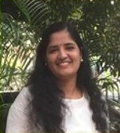 | #114 – 23 February 2023 – Mindfulness practice in every day life – Ms. Sunandha Ravi.  https://www.youtube.com/live/Ke5C9BR8VFc?feature=share  #124 – 4 May 2023 – Gratitude – Mrs. Sunandha Ravi https://www.youtube.com/live/oknboFhCYfM?feature=share  Psychologist, Motivational speaker Founder/ Maanasa Subhkara & Director/Ravi Orthocare, Hyderabad 15 years experience in the field of psychology.
Mr Nabeel Saeed  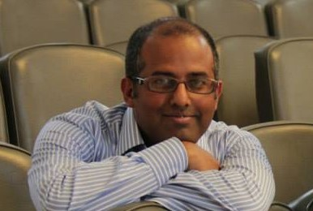 | #18 - 22 April 2021 - Global Citizenship- Nabeel Saeed https://www.youtube.com/watch?v=G2OgYx96Uf4  Nabeel Saeed - Next presenter  Nabeel is a banker by profession and a Neuro Linguistic Programming (NLP) Practitioner. Nabeel is employed with Westpac Banking Group – working in the financial crime space. When he is not investigating criminal activities in customer accounts, he is training people on public speaking, stress management, meditating and helping in changing unwanted behaviours.  Nabeel was born in a Baha’i family and have spent his life in three different continents while studying and working. During his stay in Pakistan, United Kingdom and now in Australia, he worked with different Baha’i Institutions and participated in discourses. He will be sharing a concept of ‘Global Citizenship’ in today’s extremely fast changing world.
Dr. Reza Samvat  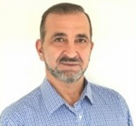 | #97 - 27 October 2022 – How our Brain is Wired for Unity – Dr. Reza Samvat http://www.youtube.com/watch?v=WtwapOT1WoE  Dr Reza Samvat is an integrated chiropractor and functional neurologist for over 30 years. Dr Samvat is a transformational coach. His focus of interest is Sleep Medicine, Hyperbaric Medicine, Brain and consciousness. He is the founder of iHeart transformational training program focusing on sustainable transformation through health creation.  He co- authored Sleep, Health & Consciousness by Reza Samvat & Henry Osiecki  He presently with his wife manages a multidisciplinary wellness centre in Gold Coast.  Listen to his informative videos @ https://www.inspiringchoices.com.au/library/
Mr. Sandy Sandanam (Mr Santhanam Sangarapillai) | #44 - 21 October 2021 - Our Minds Create Our World - Mr Santhanam Sangarapillai https://www.youtube.com/watch?v=Da4m14gYbWY  From the introduction to the presentation:  Sandy Sandanam is a trained facilitator of the National Academy of Human Values Australia. https://www.humanvaluesacademy.org/ He is a retired civil engineer based in Canberra, with a Certificate 4 in Training and Assessment, Diploma in Project Management, Bachelors Degree in Civil Engineering, and Masters in Environmental Engineering. He is also a Chartered member of Engineers Australia. He worked as a project manager with ACTWGL (?) in Canberra  and later with ACT government.
Dr Pon Satchi | #17 - 15 April 2021 - Scientific Creation and Creator Dr Pon Satchi  Balboa Press.com:  Pon Satchi is formerly a research assistant at the University of Sri Lanka, a government veterinary surgeon, served in the Ministry of Agriculture in Sri Lanka. He also served as a poultry production consultant for Omeri Farms and Feed Mills in North Yemen. Dr Pon Satchi comes from a devoted Hindu family and has a liking to follow spiritual life. He attended various spiritual group meetings and lectures, including Sai, Chimaya, Vedanta, Sadguru, and Bible study without discrimination in order to seek the truth for a happy and peaceful life. After retirement, he went into self-study and research, reading books and scientific internet publications with an open mind. Now he wants to share his recent discoveries about the truth behind creation and the Creator with other freethinkers. He is not an atheist or a canvasser.  From Amazon.com:  Publication: Nature, the True God: Updated Evidence for Unity by Pon Satchi
Sharanga Satchidandam  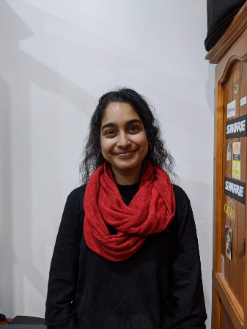 | #25 – 10 June 2021 – Lessons learned in Mindfulness – Ms Sharanga Satchidandam  https://www.youtube.com/watch?v=tF4MBmj6xUE  Miss Sharanga Satchidanandam works as the Tamil Project Officer at STARTTS (NSW Service for the Treatment and Rehabilitation of Torture and Trauma Survivors), and studies Psychology at Macquarie University. Sharanga comes from a devoted Hindu family, and felt connected to God during the process of her Bharathanatyam (traditional Indian dance form) Solo Recital. Since then she has been following a spiritual path. She completed Mental health Placement in India (2019) interested in the methods used for mental health treatment, including Ayurveda, yoga, and meditation. Here she was able to delve deeper into the concept of Mindfulness & Yoga which have had a positive impact on her life ever since. Sharanga is extremely excited to share her lessons with the Interfaith community.
Mr Peter Scandrett  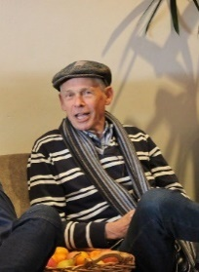 | #46 - 4 November 2021 - Jesus is the Only Way - https://www.youtube.com/watch?v=7VVPwEMp4Zg  Mr. Peter Scandrett has been a Christian and a member of the Sydney Church of Christ for the last 38 years. Although raised in a nominally Christian family, but he walked away from God while at university. He met the Sydney Church of Christ in 1982, and became a disciple in 1983. He and his wife Robin lead a home bible discussion group. Peter worked his professional career in infrastructure engineering, retiring in 2020.
Dr Thava Seelan OAM  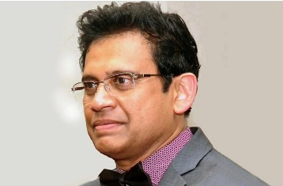 | #40 - 23 September 2021 - Pandemic and social determinants of health - Dr Thava Seelan OAM https://www.youtube.com/watch?v=LmwdSxMpcy0  Global pandemic and social determinants of health  Dr Thava Seelan, originally from Sri Lanka, has MBBS and other postgraduate qualifications FRACGP, DCH, MPH & TM from Australia. He runs Bridgeview Medical Practice, a General Practice with his wife and other multibackground, multidisciplinary team.  Dr Seelan has contributed articles in international medical journals and presented in clinical conferences.  His passion to improve the health outcomes for struggling members of society has seen him establish a local diabetes education program with community volunteers, and work abroad with emergency relief programs in Sri Lanka, where he grew up.  Dr Seelan believes that the whole person, the family, the community, and whole societal approach is the fundamental, ecological health model of primary care and was awarded OAM in 2020 for his outstanding service to the community.
Ms Merina Selvarajah | #10a - 25 February 2021 - Suffering - Ms Merina Selvarajah https://www.youtube.com/watch?v=QAlTvp21O48  Information from Facebook:  Worked at Christ Church Innerwest Anglican community  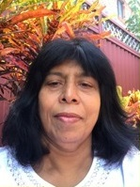
Ms. Neema Sharma  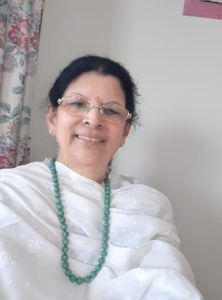 | #85 - 4 August 2022 - Gateway to a Blissful Life - Ms. Neema Sharma  Graduated from the University of the South Pacific, Fiji as a Library Assistant. Joined TAFE Multicultural Edu. Unit as an Informations officer late 80's. Went into business after taking a course in small business at TAFE. Left all that & started to pursue my spiritual journey from 2004 studying Hindu scriptures & taking pilgrimages to India, Hawaii & Fiji. Met great spiritual masters along the way. Now I mostly prefer living in silence.
Dr Lubna Siddiqi  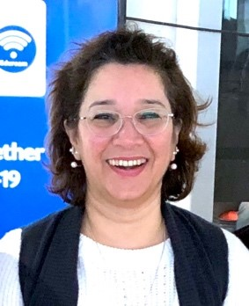 | #39 - 16 September 2021 - Spirituality and Our Life's Purpose - Dr Lubna Siddiqi https://www.youtube.com/watch?v=qDHVs0bJWTM  Dr Lubna Siddiqi is an academic and a Baháʼí, currently living in Tasmania. Hailing from multicultural family with different belief systems, and living in various countries around the world, she has developed an understanding of the nuances around diversity and inclusion. Being a curious and passionate individual, Lubna has always been interested in religion, ethics, and morality, and has participated in several interfaith dialogues and multicultural activities. Her work experience as a corporate trainer and an academic, led her towards her cross-discipline doctorate, in education and management, on the topic of ‘spirituality’, and she interviewed academics from religious, agnostic and atheist belief systems. Her findings include the different viewpoints of spirituality and its importance in developing society. She plans to continue her work overseas and will soon be moving to another continent.
Dr Jaspal Singh  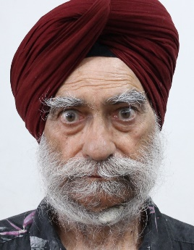 | #36 - 26 August 2021 - Some aspects of Sikh Faith - Dr Jaspal Singh  Dr Jaspal Singh has MBBS; MD (From Rajindra Medical College Patiala). He retired in 2009 as Chief Medical officer in Punjab Government service in India. Since retirement, he worked as faculty member at Lovely Professional University, Phagwara, Punjab, India for 9 years. Now living in Australia since 2019 as PR. His hobbies include listening to divine music, reading articles, books, magazines and literature by literary authors on Sikh faith, and Sikh Scripture.
Mr. S. Sowrirajan  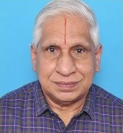 | #107 – 5 January 2023 – Ramanuja Acharya – Mr. Sowrirajan ( Ref https://en.wikipedia.org/wiki/Ramanuja) https://www.youtube.com/watch?v=LWSv6wCIzIM  Mr. S.Sowrirajan M.A., M.Sc., M.Ed.  Retired Lecturer in Gov. HSS (Junior College) Karaikal, Interested in writing poems in Tamil and English.
Ms. Inba Subramaniam  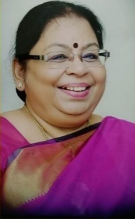 | #69 - 14 April 2022 - Human Psychology - Ms. Inba Subramaniam  http://www.youtube.com/watch?v=_hC1FhYJ-jw  Ms. Inba Subramanian is from Tamil Nadu India. She is a Psychologist, Counsellor, Author, Healer.  She was the counsellor for many schools, universities and organisations and individuals. She prevented many young people from committing suicide. She wrote many books in Tamil and received best writer award from Tamil Nadu government twice.  She researched and studied about astrology, pranic healing, reiki. She is the Founder of Universal Prana Reiki and conducts training on this method of healing.
Dr. Chandika Subramaniyan  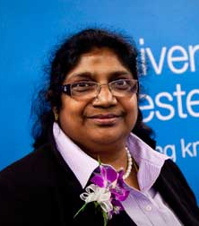 | #9 - 18 February 2021 - Domestic Violence - Dr. Chandika Subramaniyan https://www.youtube.com/watch?v=BUS230iufmM  From the introduction to the presentation:  Chandika active in the community to bring about peace and unity and justice in many ways. She is an author and speaker.  From https://www.shremaya.org.au/profile/chandrika-subramaniyan  Dr Chandrika Subramaniyan, a Solicitor and Barrister, Supreme Court of NSW and High Court of Australia. She is an active community leader, scholar and orator, with wealth of knowledge. She received an award, ‘Overseas Tamil Scholar 2019’fromGovernment of Tamilnadu’ in recognition of her literary and cultural contribution in Australia. Her achievements include: Premier’s Harmony Medal Winner 2019-NSW State Citizen of the Year 2019-Cumberland Council Women of the West 2012 - University of West,
Ms.Katarzyna Syta  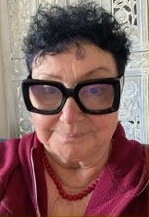 | #98 - 3 November 2022 – Religions versus spirituality. The core of all religions – Ms.Katarzyna Syta http://www.youtube.com/watch?v=BaVNZop5nEk  Katarzyna recently works at Urban Healers as energy healer, past life regressionist, tract emotions releaser, shamanic healing and Tarot Reader.  By education and work experience she is Master of Engineering Science but at her core she is mathematician , philosopher, writer (author), cook and healer.  After retiring from engineering she broadly studied many branches of religious studies, psychologies philosophies, anthropology, sociology, astronomy, IT, ancient history and others mostly at the CCE University of Sydney.Recently she works as a healer and finishing her third book (the first in English).
Mr. Balavelan Thanigaivelan  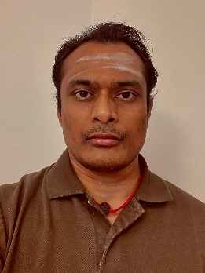 | #72 - 5 May 2022 – Precious Human Life - by Avvaiyaar - Mr. Balavelan Thanigaivelan  Mr. Balavelan is an Engineer by Profession who holds a Masters Degree in Electrical Engineering. He works as an Integrated Circuit Design Engineer for a Semiconductor Industry. He comes from a Shaiva Religious Family. He was introduced to traditional Thiruppugazh singing since childhood. He then studied professional Thirumurai Singing and completed a degree from Koviloor Adheenam. He also completed a course on Siva Gnana Botham conducted by World Saiva Council Australia and is currently enrolled in course on Siva Gnana Thirumurai Vilakkam. Mr. Balavelan believes in continuous learning and is passionate about exploring Saiva scriptures in both Tamil and Sanskrit.
Dr. Marjorie Tidman  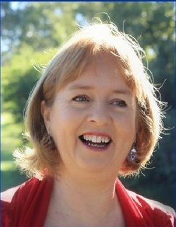 | #51 - 9 December 2021 - Sifting the Dust: God and the Mad Psychologist - Dr Marjorie Tidman https://www.youtube.com/watch?v=VKCQgiwl-Tk  Marjorie Tidman has a first class Honours Degree from Sydney University and was awarded the University Medal; and a Doctorate in Educational Psychology from Murdoch University. Until recently retiring she was a registered Psychologist in Australia. She began her career working with children, families and classrooms within school settings; then established a private practice which involved serving populations in remote regions of Western Australia. For 15 years she specialised in responding to those impacted by sudden trauma whether individuals, families, organisations or communities across Western Australia and including some remote islands. Her university research, voluntary community service and professional trauma response work have been recognised by university, state and national awards. Marjorie has been a long-standing member of the Australian Baha'i Community and served on its national governing body for 12 years.
Mr Sana Vasli  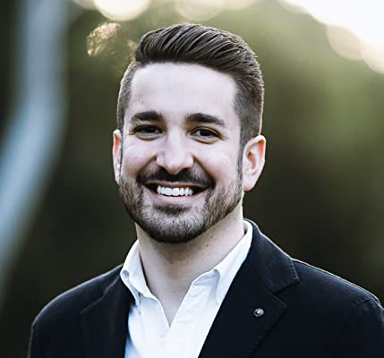 | #30 – 15 July 2021 – See the Good in Others – Mr Sana Vasli  https://www.youtube.com/watch?v=WZD-r2ttDY0  Sana has a young family, and has been a member of the Baha’i community from his childhood. He works in the banking industry in a strategy and operations department.
Mr Vasudevan Veerasamy  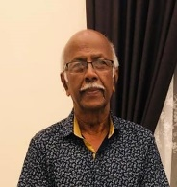 | #32 - 29 July 2021 - Importance of Prayer - Mr Vasudevan Veerasamy https://www.youtube.com/watch?v=vhk2ncaVIU4  Mr. Vasudevan Veerasamy is 78 year old Malaysian Baha’i. He accepted Baha'u'llah in April 1967. Having lost his wife and a son, youngest of four children, he now lives with his eldest daughter and her two children.
Mrs Arini Verwer  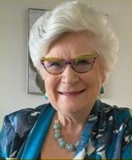 | #105 – 22 December 2022 – How do we learn to be Virtuous? – Dr. Arini Verwer https://www.youtube.com/watch?v=q-GeU3oqeQk  Dr Arini Verwer has a Doctoral Degree in Moral Education, she was interested as an educator in the reason why we know what to do yet do not do it. She explored what is the gap and how do we bridge from judgement to action. She was able to use this information to develop a series of children's books the Super Six Heroes to help parents to educate a child to learn to make wiser choices. Currently she is a family coach and educator after spending the majority of her career as an educational leader and management consultant. She spent 20 years serving on the national administrative body of the Baha'i community in Australia. She served for 3 years as the Principal of Maxwell International Baha'i School in Canada.  https://relationshipinfinity.com/
Dr. Ganesh Vinayahan  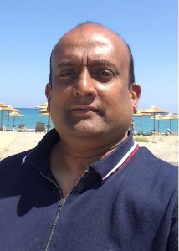 | #128 -1 June 2023 – The Life After and NDE (Near Death Experience) – Dr. Ganesh Vinayahan.  https://www.youtube.com/live/nUbHhLGQXzQ?feature=share  Dr. Ganesh Vinayahan  Working at Royal Preston Hospital as Oral and Maxillofacial surgery for 18yrs  Migrated to UK from Srilanka  Has been incorporating spiritual practices taught by Brahma Kumaris Raja Yoga at work and family life
Mr David Vohradsky  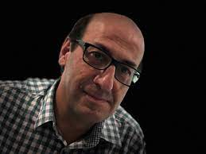 | # 14 - 25 March 2021 - Love thy Neighbour - Mr David Vohradsky  David Vohradsky is a cybersecurity advisor to the University of Sydney and has previously held senior‐level positions at Protiviti, Commonwealth Bank, NSW Transport, Macquarie Bank, and Tata Consultancy Services.  David has also previously served as the Federal Vice President of the United Nations Association of Australia overseeing educational programs in the areas of human rights, environment, refugees, peace and disarmament, social development, religion, women, and youth.
Mr. Peter Warren  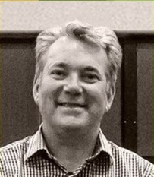 | #78 – 16 June 2022 – Your Superpower – Mr. Peter Warren  Peter Warren has been a student of Interfaith since 2005 as a member of Rev Stephanie Dowrick's Interfaith service which met in Pitt Street Uniting Church. His background is Christianity and has since been a student of Buddhism, Hindu and Islam. He is married with 4 grown sons and works as a Project Manager.
Mr. Arvid Yaganegi  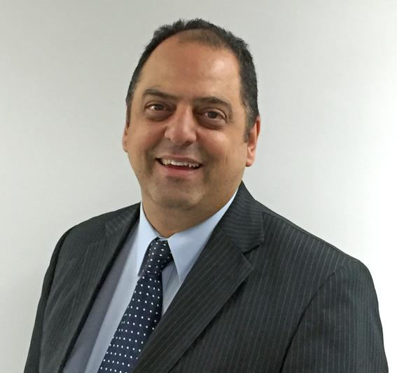 | #37 - 2 September 2021 - Wayfarer's mystic journey - Mr Arvid Yaganegi https://www.youtube.com/watch?v=ZQ9-fWqOLuI  Mr. Arvid Yaganegi has worked in senior management in the Vocational Education sector spanning over 30 years in Australia and Eastern Europe. He recently finished his five-year term as a Director for the federal regulator and now works in compliance management in the university sector. He has served on various boards and executive committees related to his field. He has an MBA, Grad Dip VET and BSc.  Arvid’s grandfather came across the Bahá’i faith in the 1920s through hearing commentaries about the mystical works and poems of Rumi, a 13th century Persian poet. This has been an area of interest for Arvid over the years and he will share some of his thoughts.
Mr. Zia Ziaei  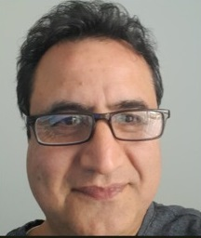 | #127 – 25 May 2023 – Constructive Resilience – Mr Zia Ziaei https://www.youtube.com/live/CCmy5AKjiqM?feature=share  Mr. Zia Ziaei is an IT Consultant and the Director of “Global Technet Co.” He is a Baha’i from Iran where he suffered persecution. He has been serving in numerous Baha’i communities in Australia as part of the training institute and also has served as an IT volunteer at the Baha’i World Centre, Haifa – Israel, for over 7 years.

