Charles Geoffrey Dibdin
1930 – 2014
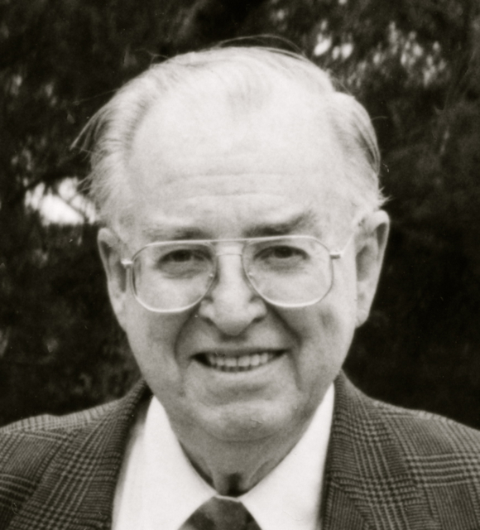

MEMORIAL SERVICE
10 January, 2014
Mt Barker, South Australia
Welcome & Introduction

Prayer for the Departed

O my God! O my God! Verily, thy servant, humble before the majesty of Thy divine supremacy, lowly at the door of Thy oneness, hath believed in Thee and in Thy verses, hath testified to Thy word, hath been enkindled with the fire of Thy love, hath been immersed in the depths of the ocean of Thy knowledge, hath been attracted by Thy breezes, hath relied upon Thee, hath turned his face to Thee, hath offered his supplications to Thee, and hath been assured of Thy pardon and forgiveness. He hath abandoned this mortal life and hath flown to the kingdom of immortality, yearning for the favor of meeting Thee.

O Lord, glorify his station, shelter him under the pavilion of Thy supreme mercy, cause him to enter Thy glorious paradise, and perpetuate his existence in Thine exalted rose garden, that he may plunge into the sea of light in the world of mysteries.

Verily, Thou art the Generous, the Powerful, the Forgiver and the Bestower.

'Abdu’l-Bahá

Selection from
The Hidden Words of Bahá'u'lláh

O SON OF BEING!
Love me, that I may love thee. If thou lovest Me not, My love can in no wise reach thee. Know this, O servant.

O SON OF THE SUPREME!
I have made death a messenger of joy to thee. Wherefore dost thou grieve? I made the light to shed on thee its splendor. Why dost thou veil thyself therefrom?

O SON OF BEING!
Thou art My lamp and My light is in thee. Get thou from it thy radiance and seek none other than Me. For I have created thee rich and have bountifully shed My favor upon thee.

O SON OF SPIRIT!
With the joyful tidings of light I hail thee: rejoice!
To the court of holiness I summon thee; abide therein that thou mayest live in peace for evermore.

O SON OF BEING!
Thy Paradise is My love; thy heavenly home, reunion with Me. Enter therein and tarry not. This is that which hath been destined for thee in Our kingdom above and Our exalted dominion.

O SON OF SPIRIT!
Burst thy cage asunder, and even as the phoenix of love soar into the firmament of holiness. Renounce thyself and, filled with the spirit of mercy, abide in the realm of celestial sanctity.

O SON OF JUSTICE!
Whither can a lover go but to the land of his beloved and what seeker findeth rest away from his heart’s desire? To the true lover, reunion is life, and separation is death. His breast is void of patience and his heart hath no peace. A myriad lives he would forsake to hasten to the abode of his beloved.

***

Gleanings from the Writings of Baha'u'llah

The nature of the soul after death can never be described, nor is it meet and permissible to reveal its whole character to the eyes of men. The Prophets and Messengers of God have been sent down for the sole purpose of guiding mankind to the straight Path of Truth. The purpose underlying Their revelation hath been to educate all men, that they may, at the hour of death, ascend, in the utmost purity and sanctity and with absolute detachment, to the throne of the Most High.
The light which these souls radiate is responsible for the progress of the world and the advancement of its peoples. They are like unto leaven which leaveneth the world of being, and constitute the animating force through which the arts and wonders of the world are made manifest. Through them the clouds rain their bounty upon men, and the earth bringeth forth its fruits. All things must needs have a cause, a motive power, an animating principle. These souls and symbols of detachment have provided, and will continue to provide, the supreme moving impulse in the world of being. The world beyond is as different from this world as this world is different from that of the child while still in the womb of its mother. When the soul attaineth the Presence of God, it will assume the form that best befitteth its immortality and is worthy of its celestial habitation.

Eulogy

Photographic Montage of the
Life of Geoff Dibdin

Gleanings from the Writings of Baha'u'llah

Sorrow not if, in these days and on this earthly plane, things contrary to your wishes have been ordained and manifested by God, for days of blissful joy, of heavenly delight, are assuredly in store for you. Worlds, holy and spiritually glorious, will be unveiled to your eyes. You are destined by Him, in this world and hereafter, to partake of their benefits, to share in their joys, and to obtain a portion of their sustaining grace. To each and every one of them you will, no doubt, attain.

Departure for Mt Barker Cemetery
Doddow Rd, Mt Barker, South Australia

Graveside Ceremony

Prayer for the Departed

O my God! This is Thy servant and the son of Thy servant who hath believed in Thee and in Thy signs, and set his face towards Thee, wholly detached from all except Thee. Thou art, verily, of those who show mercy the most merciful.

Deal with him, O Thou Who forgivest the sins of men and concealest their faults, as beseemeth the heaven of Thy bounty and the ocean of Thy grace. Grant him admission within the precincts of Thy transcendent mercy that was before the foundation of earth and heaven. There is no God but Thee, the Ever-Forgiving, the Most Generous.

Let him, then, repeat six times the greeting “Alláh-u-Abhá,” and then repeat nineteen times each of the following verses:

We all, verily, worship God.
We all, verily, bow down before God.
We all, verily, are devoted unto God.
We all, verily, give praise unto God.
We all, verily, yield thanks unto God.
We all, verily, are patient in God.

Bahá’u’lláh
Prayer for Humanity
O Thou kind Lord! Thou hast created all humanity from the same stock. Thou hast decreed that all shall belong to the same household. In Thy Holy Presence they are all Thy servants, and all mankind are sheltered beneath Thy Tabernacle; all have gathered together at Thy Table of Bounty; all are illumined through the light of Thy Providence.
O God! Thou art kind to all, Thou hast provided for all, dost shelter all, conferrest life upon all. Thou hast endowed each and all with talents and faculties, and all are submerged in the Ocean of Thy Mercy.

‘Abdu’l-Bahá

‘I am the Dust’
Song by Peter Tidman and Family
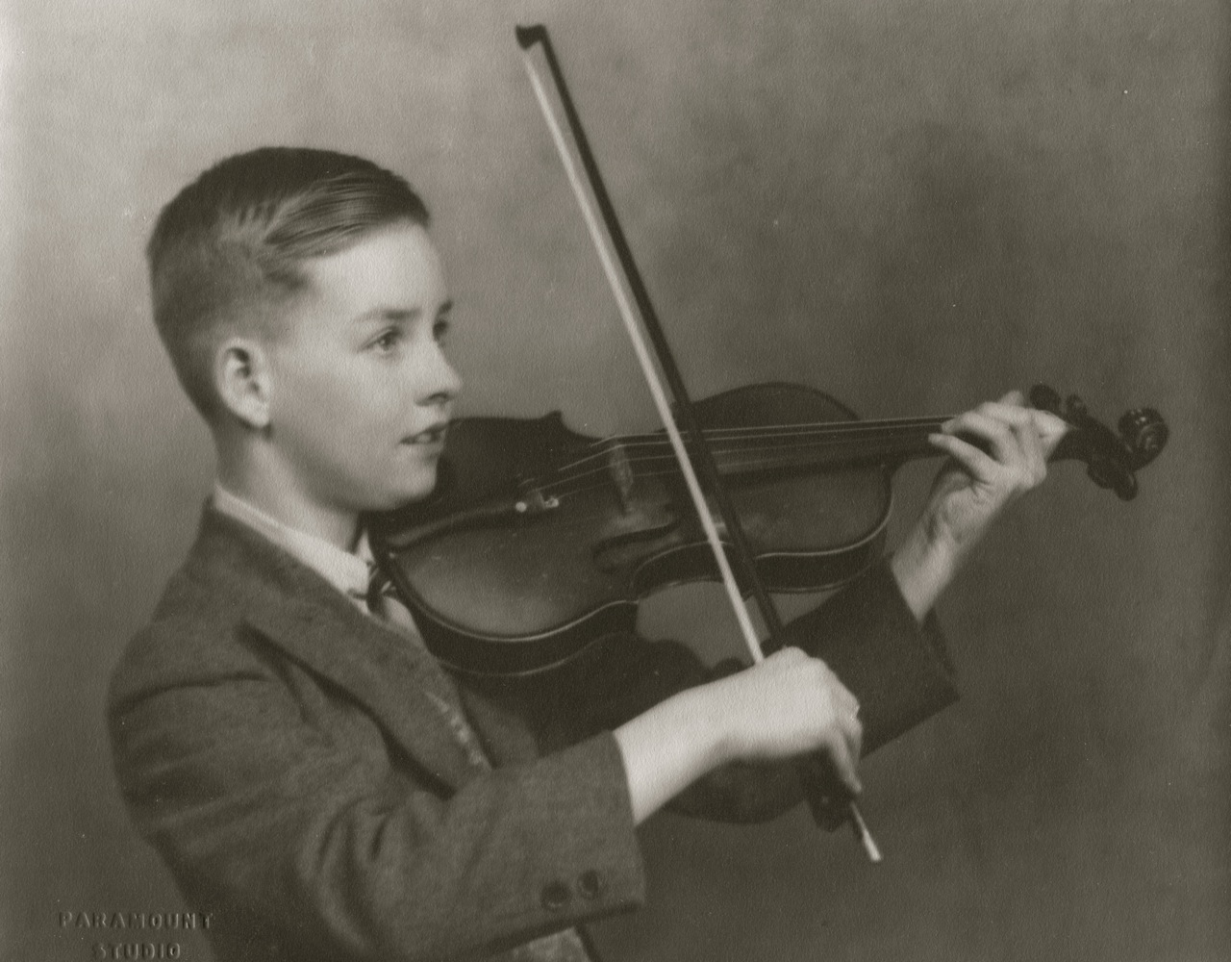

Please join us for Refreshments
Kleeman & Family: 1 Morphett St, Mt Barker

